

Lab Manual
Subject: Data Mining

By
M Zubair Khan 2023-BS-AI-006
Semester 6th
Supervised by Sir Arham
The University of Faisalabad
Bachelors of Science in Artificial Intelligence

Lab # 1

KNIME Introduction
Real-World Problem
- A retail company has sales transaction data but needs analysis to gain business insights.
- Goals:
  - Measure total revenue
  - Calculate average customer spending
  - Identify top-performing categories
  - Find the most profitable products
Dataset
Contains transaction-level sales records:
- Transaction ID
- Product Name
- Product Category
- Quantity
- Price per Unit
- Order Date
- Revenue (Total Amount)
Software Environment: KNIME Analytics Platform
- A visual, node-based data analytics tool.
- Uses connected nodes to read, process, analyze, and visualize data.
Practical Objectives
Students will learn to:
- Import CSV data using the CSV Reader node.
- Verify and correct data types.
- Generate descriptive statistics.
- Create a Revenue column using the Math Formula node.
- Calculate key retail KPIs using GroupBy and Sorter nodes.
Key Performance Indicators (KPIs)
- Total Revenue
- Average Order Value
- Highest Revenue Category
- Most Profitable Product
Outcome
- Transform raw sales data into meaningful business insights using a structured KNIME workflow.

Procedure

Step 1: Download the Dataset
Obtain the Retail Sales dataset in CSV format from the provided source and save it locally for analysis.
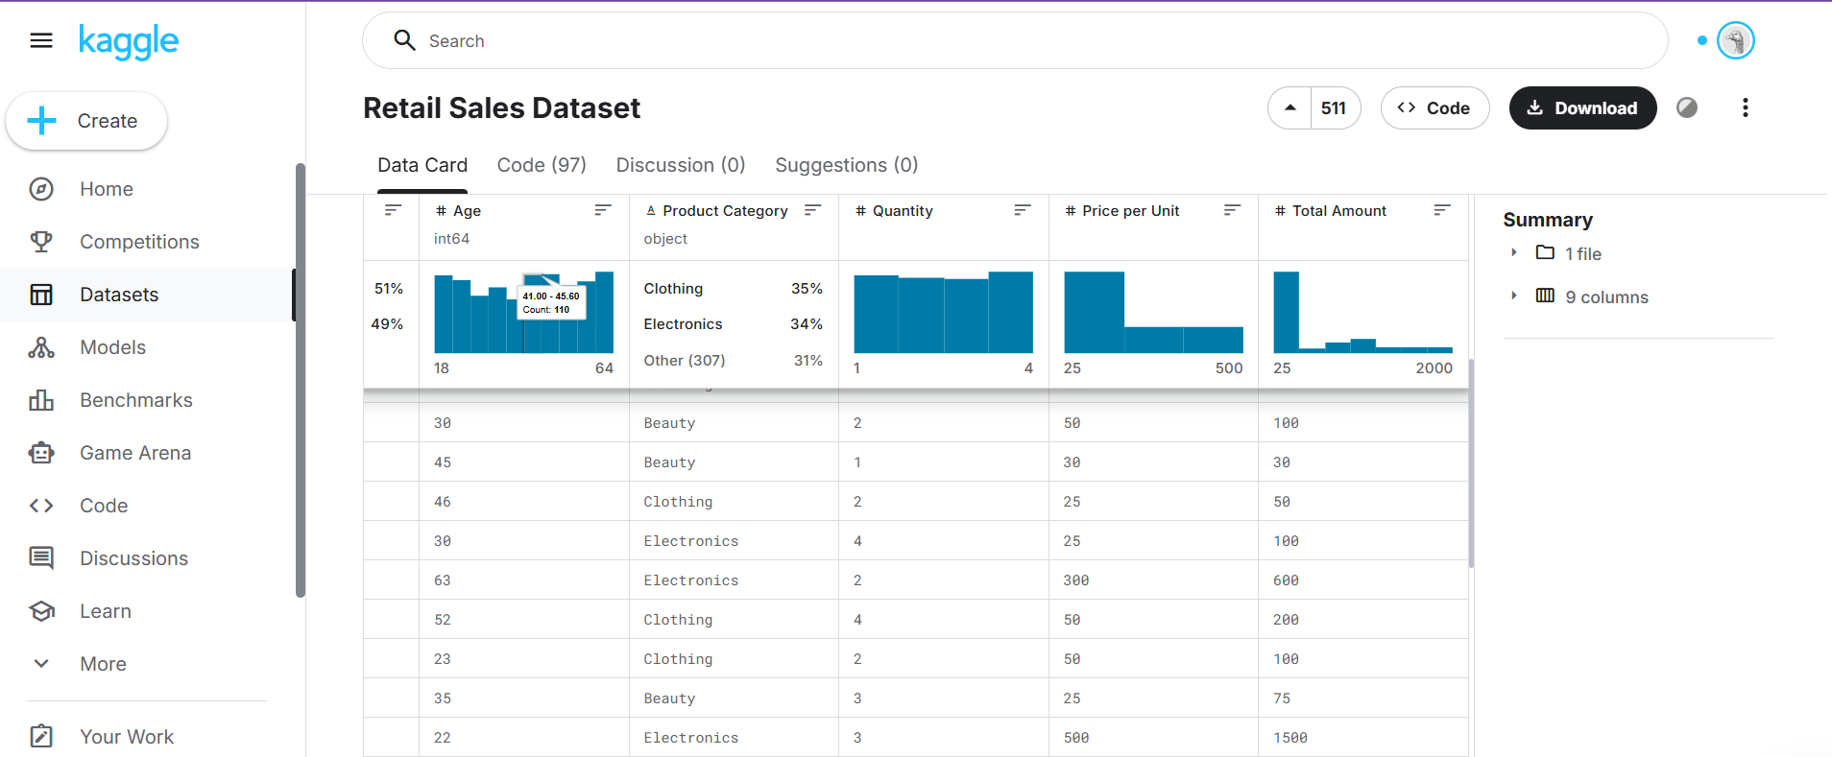

Step 2: Create a New Workflow
Launch KNIME Analytics Platform and create a new workflow named Retail Sales Analysis to organize the analytical process.
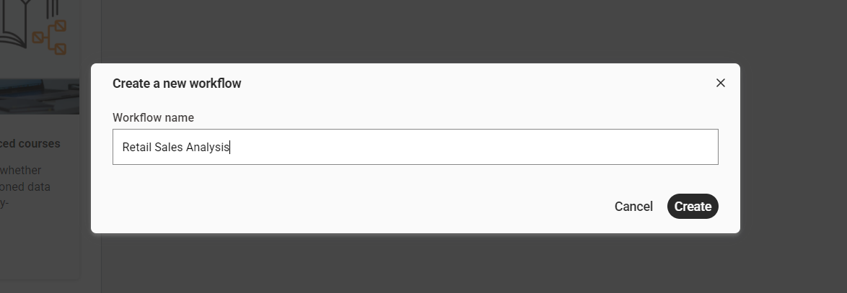

Step 3: Import the Dataset
Use the CSV Reader node to load the Retail Sales dataset into the workflow environment and verify successful execution.
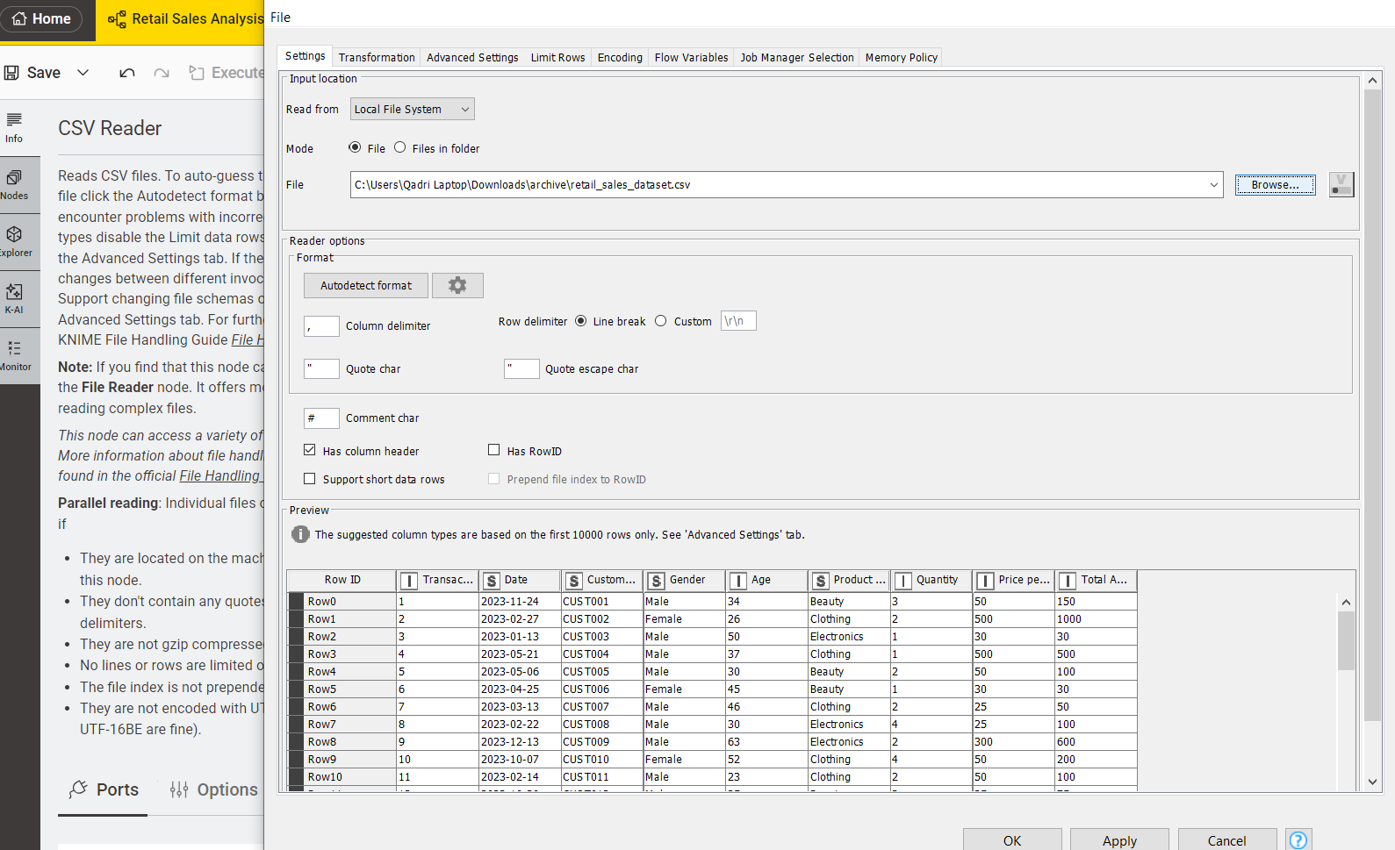

Step 4: Verify the Data Types
Inspect all columns to ensure numeric fields (Quantity, Price, Revenue) are correctly typed as Integer or Double, and categorical fields (Category, Product Name) are set as String.
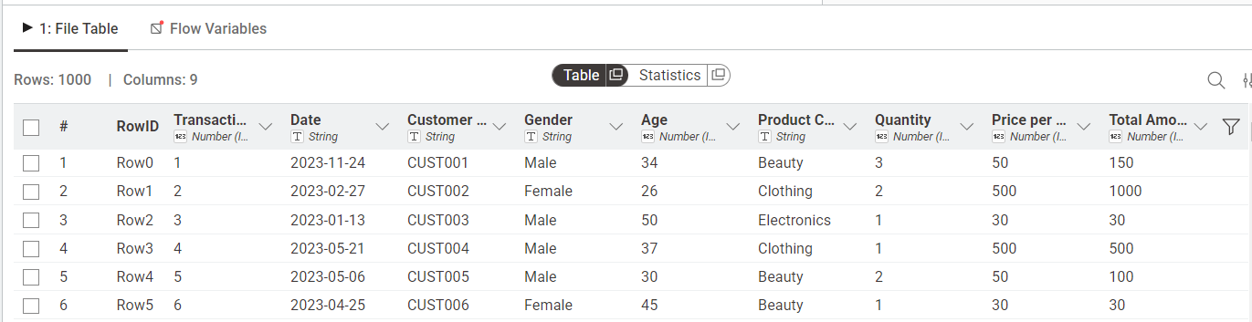

Step 5: Generate Summary Statistics
Apply the Statistics node to compute descriptive measures such as mean, minimum, maximum, sum, and standard deviation for numeric attributes.
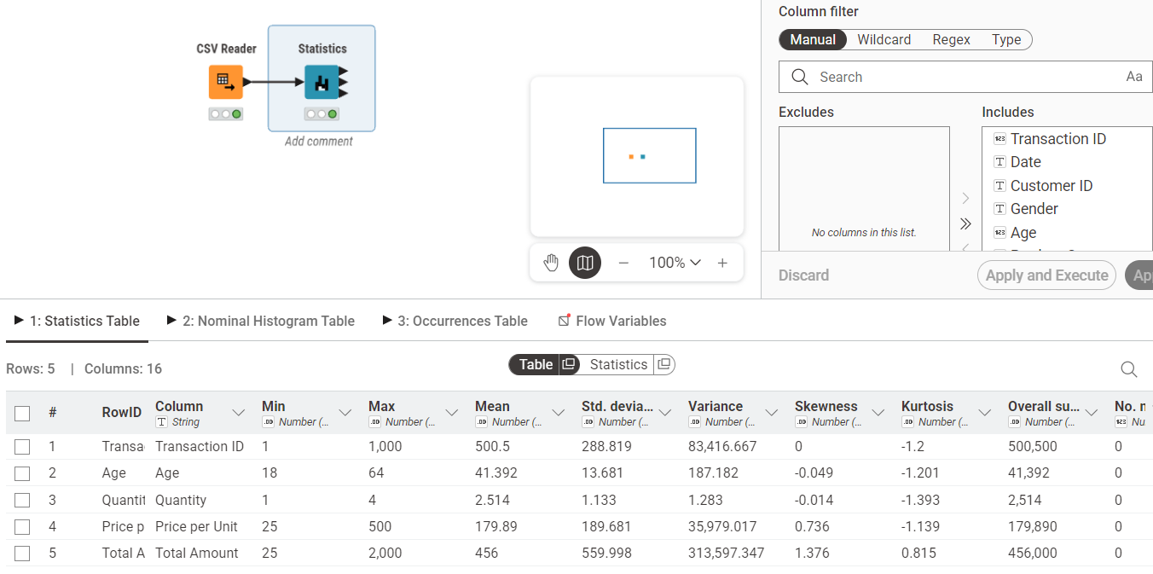

Step 6: Calculate Revenue Column
Use the Math Formula node to create a new Revenue column using the formula:
Revenue = Quantity × Price
This derived column will be used for KPI calculations.
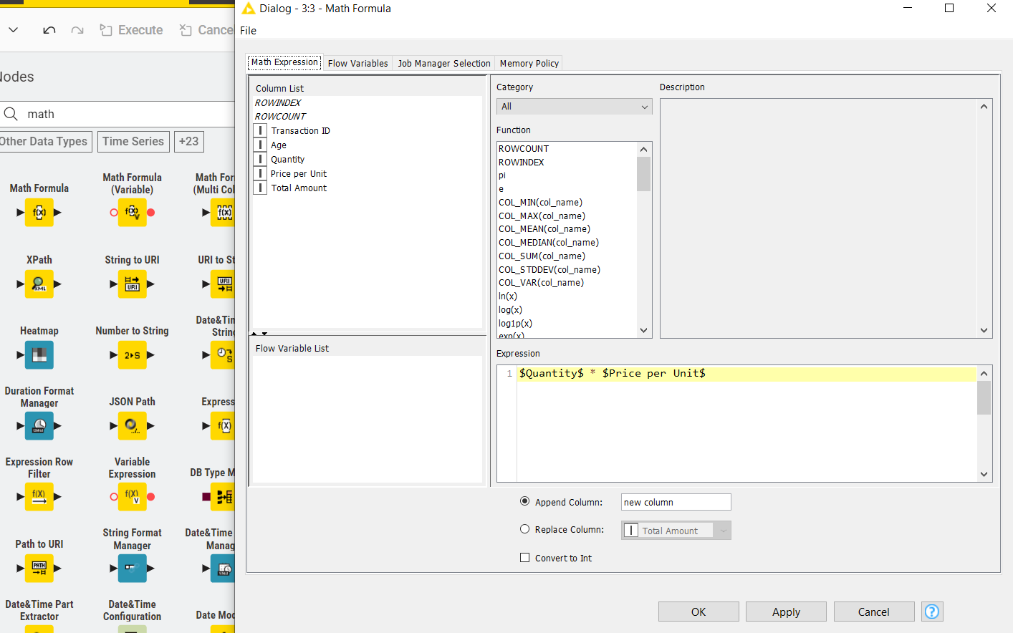
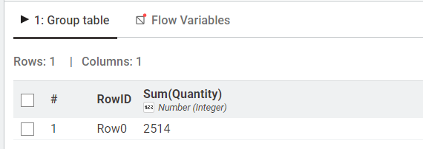

Step 7: Calculate Total Revenue (KPI 1 – Total Revenue)
Add a GroupBy node without selecting any grouping column and aggregate the Revenue column using the Sum function to compute overall sales revenue.
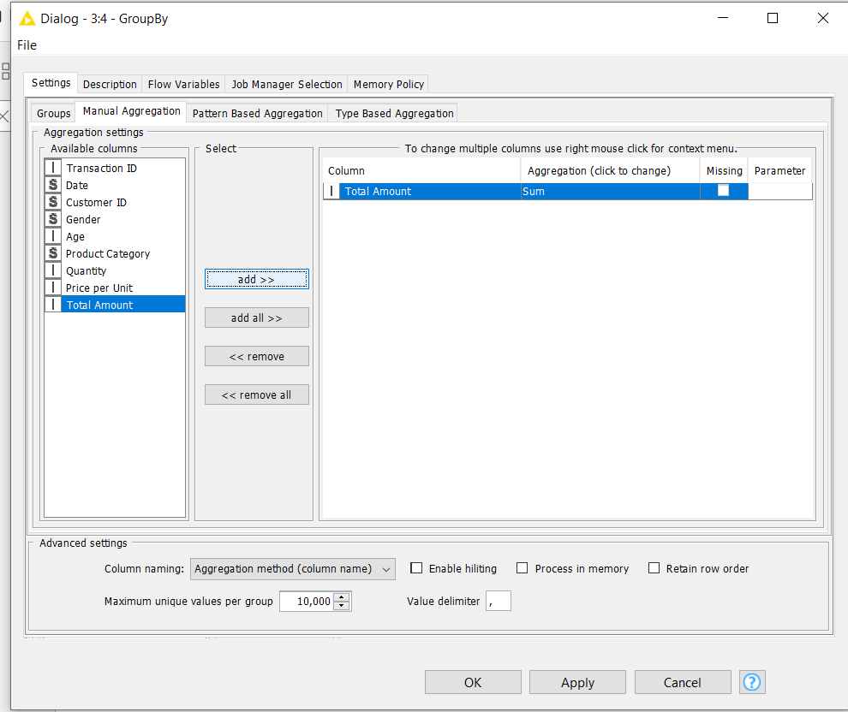

Step 8: View Total Revenue Result
Execute the node and observe the single output value representing total revenue across all transactions.
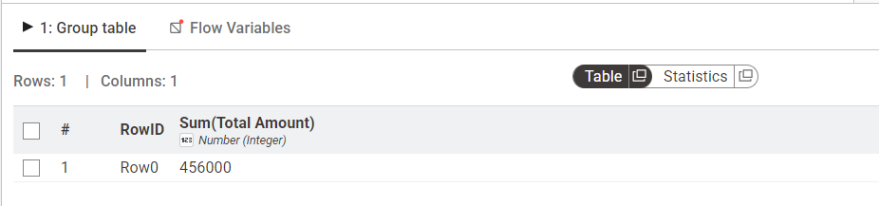

Step 9: Calculate Revenue per Transaction
Add a GroupBy node, group by Transaction ID, and aggregate Revenue using Sum to compute total revenue for each individual order.
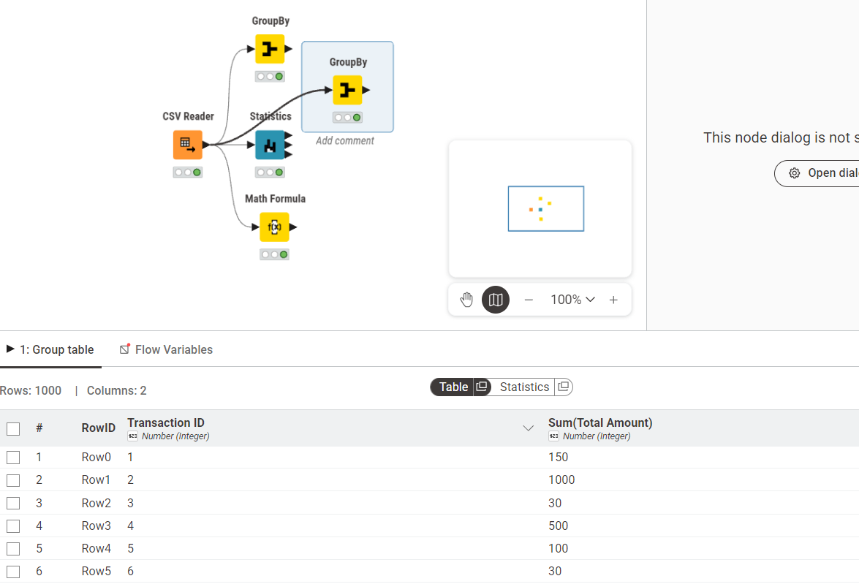

Step 10: Calculate Average of All Orders (KPI 2 – Average Order Value)
Connect a second GroupBy node with no grouping column and calculate the Mean of the aggregated revenue to determine the average order value.
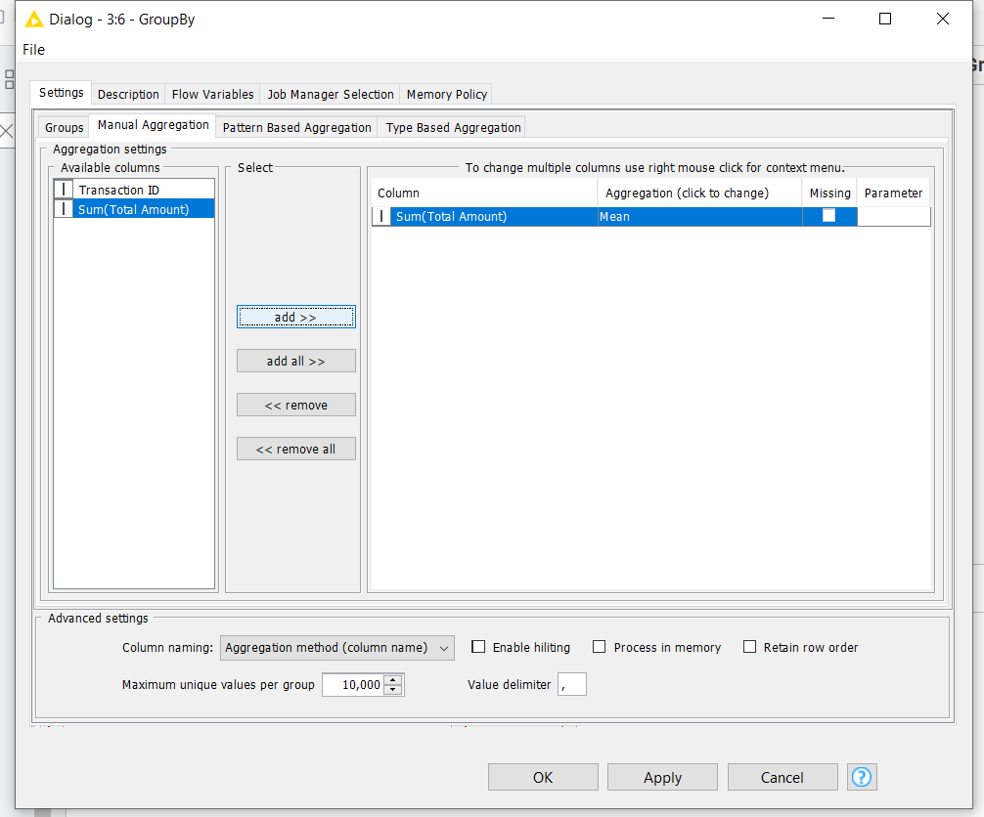

Step 11: View Average Order Value Result
Execute and review the output showing the average revenue generated per transaction.
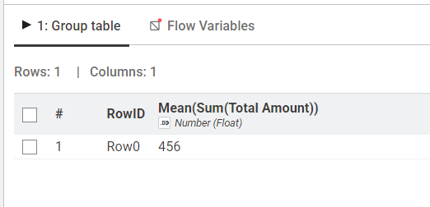

Step 12: Calculate Category Revenue (KPI 3 – Revenue by Category)
Add a GroupBy node and group by Product Category. Aggregate Revenue using Sum to compute total earnings for each category.
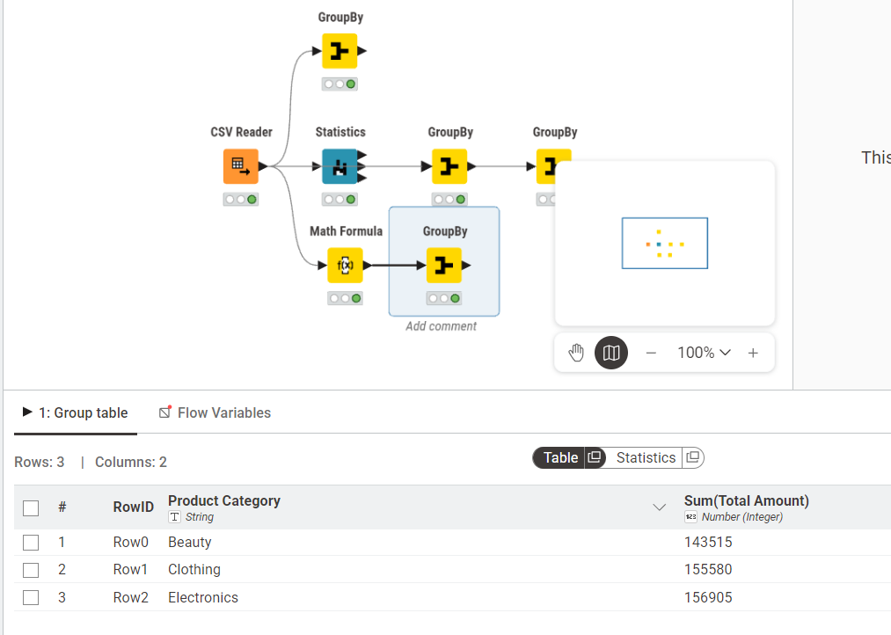

Step 13: Sort to Identify Highest Revenue Category
Connect a Sorter node and configure it to sort revenue values in descending order to rank categories from highest to lowest.
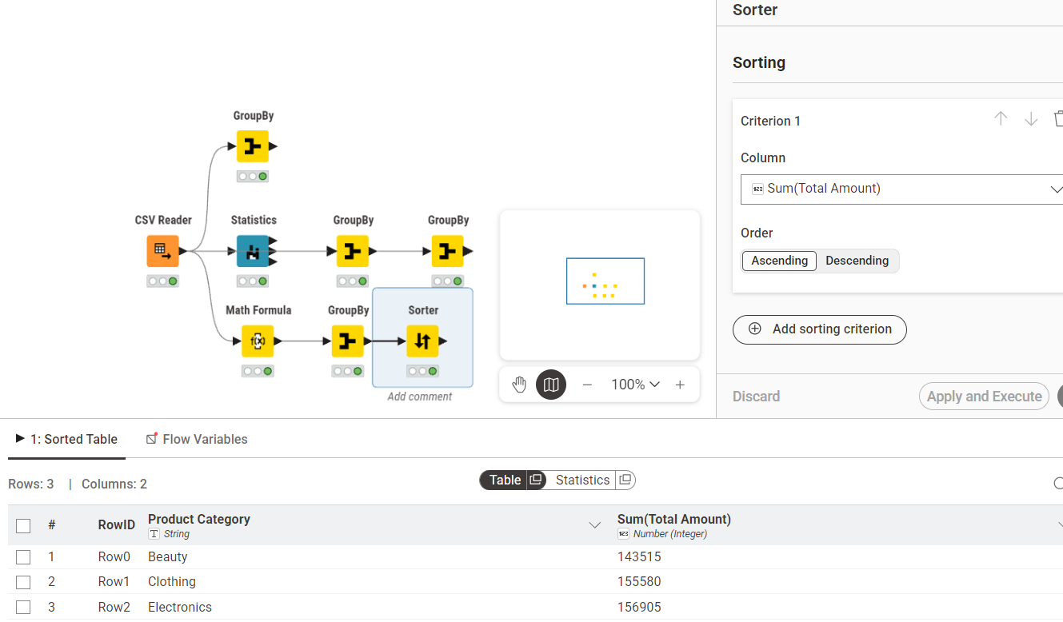

Outcome of the Lab
This lab demonstrates how raw transactional sales data can be systematically transformed into structured performance metrics.
The workflow converts:
Raw Data → Processed Data → Aggregated Metrics → Business Insights
Through structured node-based operations, the analysis provides measurable indicators that support revenue evaluation, category comparison, and product performance assessment.

Lab # 2
Customer Churn Prediction

Real-World Problem
- An e-commerce company wants to predict customers who may stop using its service (churn).
- Early prediction helps improve customer retention and reduce revenue loss.
Dataset
- Churn_Modelling.csv
- 10,000 customer records with 14 attributes.
- Target Variable:
  - Exited = 1 → Churned
  - Exited = 0 → Retained
- Important features:
  - CreditScore
  - Geography
  - Gender
  - Age
  - Tenure
  - Balance
  - NumOfProducts
  - HasCrCard
  - IsActiveMember
  - EstimatedSalary
- Removed columns:
  - RowNumber
  - CustomerId
  - Surname
Software Environment: Orange Data Mining
- Open-source visual analytics tool.
- Builds data mining workflows using drag-and-drop widgets without coding.
Practical Objectives
- Load and inspect data using File and Data Table widgets.
- Remove unnecessary columns and set the target variable using Select Columns.
- Preprocess data (normalize and encode features).
- Train Logistic Regression and Random Forest models.
- Evaluate models using 10-fold Cross Validation.
- Analyze results with Confusion Matrix and ROC Analysis.
- Calculate business KPIs:
  - Churn Rate
  - Retention Rate
Outcome
- Build and evaluate a customer churn prediction model to help businesses identify at-risk customers and improve retention strategies.
Procedure
Step 1: Load the Dataset
Use the File widget to load Churn_Modelling.csv and connect it to a Data Table widget to verify all 10,000 rows and 14 columns are loaded correctly.

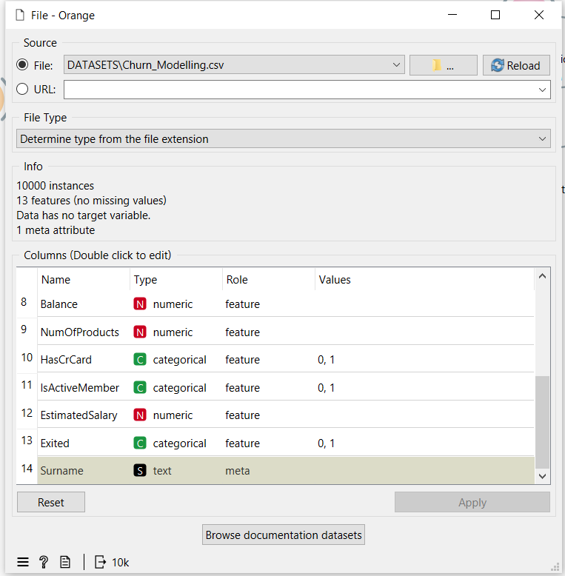
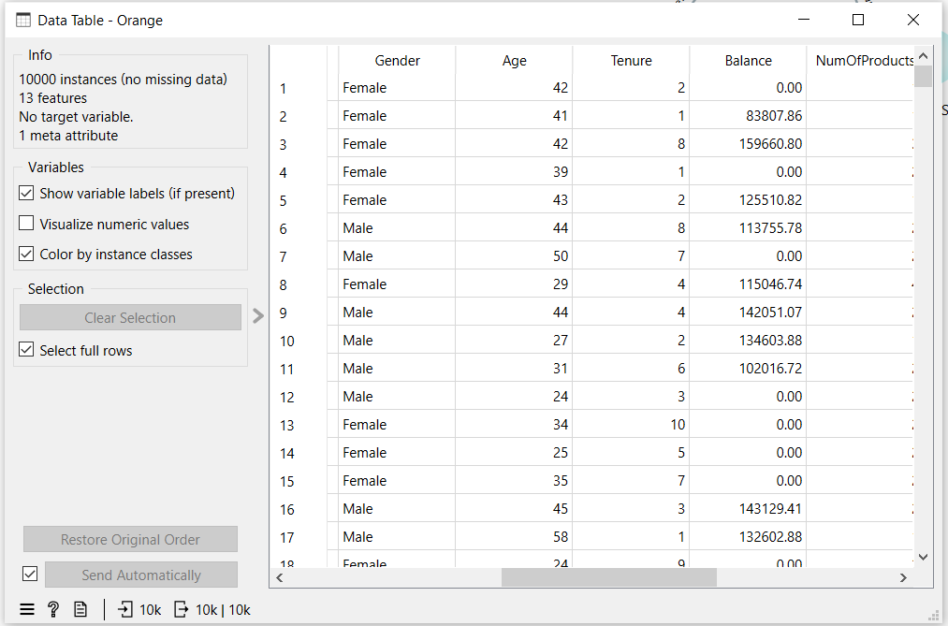
Step 2: Select Columns
Connect to a Select Columns widget. Move RowNumber, CustomerId, and Surname to the Ignore list. Set Exited as the Target class and keep all remaining features.
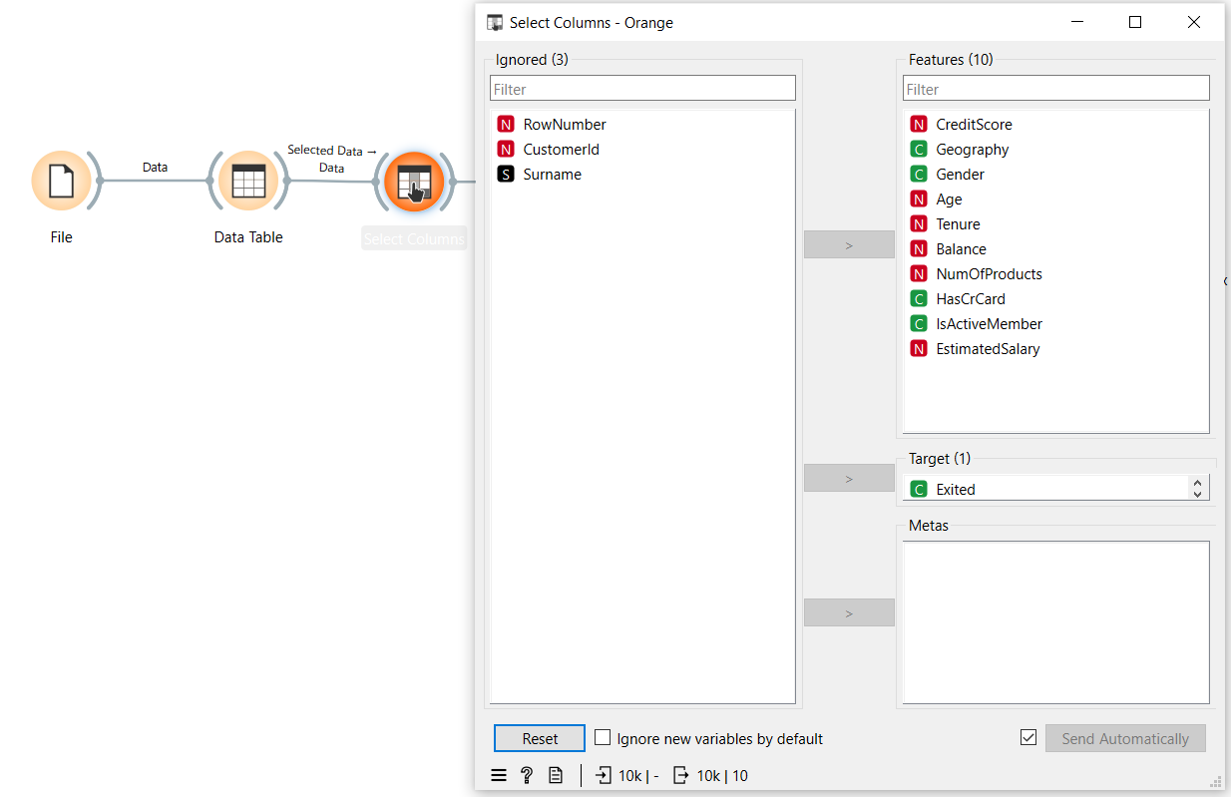
Step 3: Preprocess
Connect to a Preprocess widget and enable Min-Max normalization to scale all numeric features between 0 and 1.
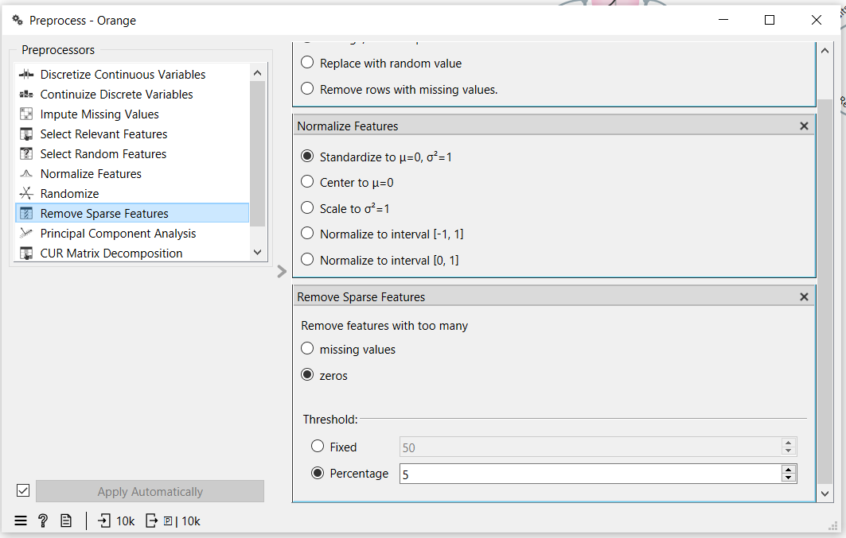
Step 4: Add Models
Connect the Preprocess widget to both a Logistic Regression widget and a Random Forest widget using the Preprocessor output port.
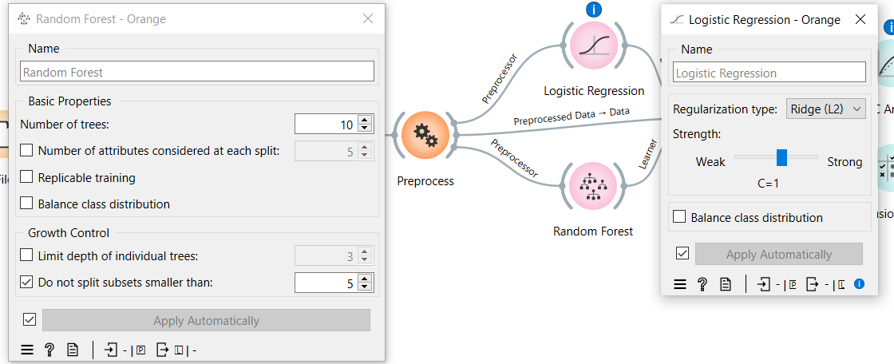
Step 5: Test and Score
Connect both learners and the preprocessed data to the Test and Score widget. Set evaluation to Cross Validation with 10 folds and enable Stratified splitting.
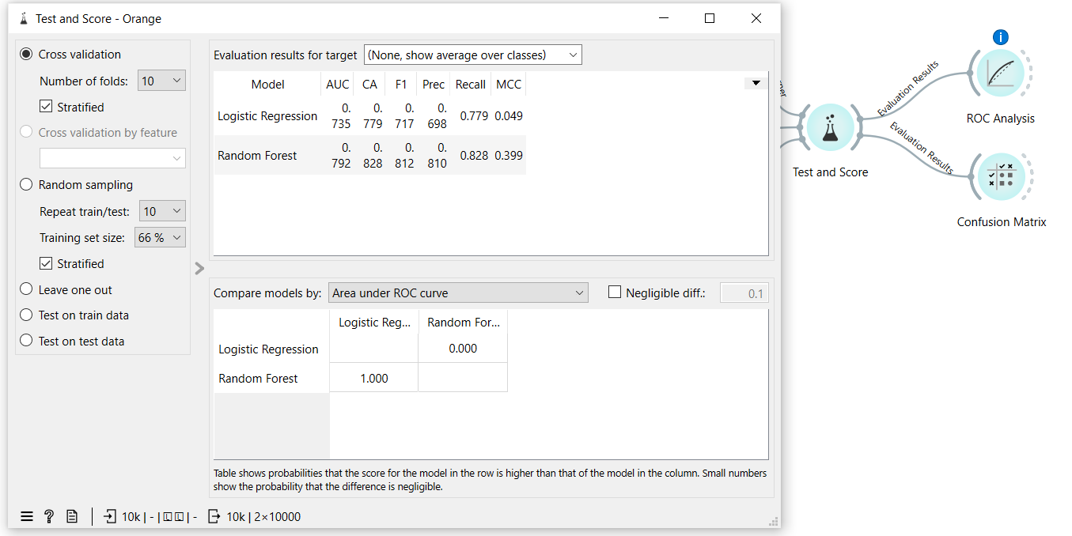
Step 6: Evaluate
Connect Test and Score to a ROC Analysis widget and a Confusion Matrix widget to visualize model performance.
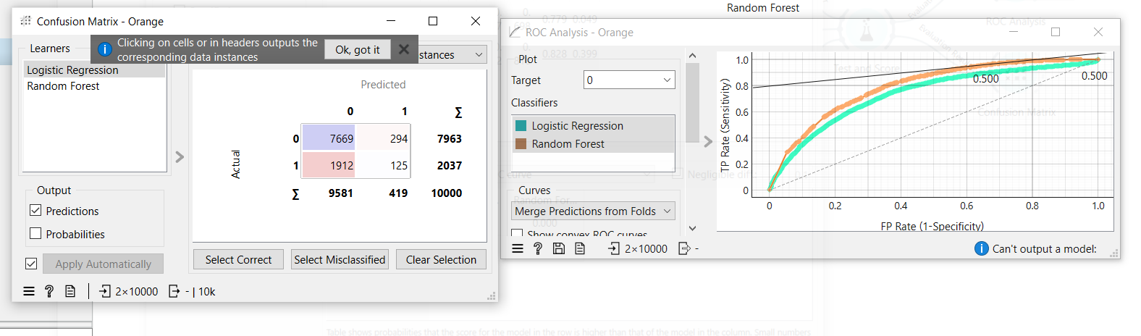
Outcome of the Lab
This lab demonstrates how raw customer data can be processed and modeled to predict churn using a complete CRISP-DM pipeline in Orange.
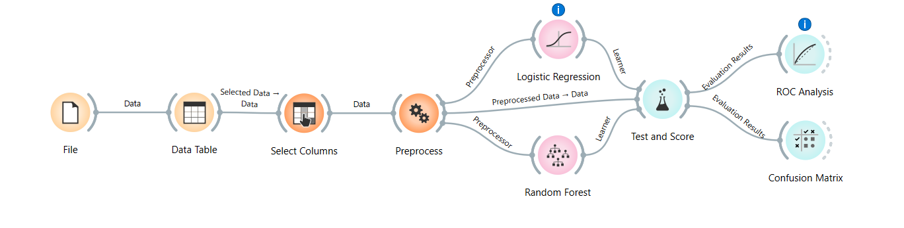
Random Forest outperformed Logistic Regression across all metrics. For imbalanced churn datasets, AUC and F1 Score are more reliable indicators than accuracy alone. The model can be deployed to score customers and trigger early retention actions for high-risk segments.
KPI | Result
Churn Rate | 20.37%
Retention Rate | 79.63%
Logistic Regression AUC | 0.735
Random Forest AUC | 0.792
Random Forest Accuracy | 82.8%
Random Forest F1 Score | 0.812

Lab # 3

Data Cleaning

Real-World Problem
- Healthcare datasets often contain missing values, duplicate records, and invalid data (e.g., negative billing amounts).
- Data cleaning is necessary to improve accuracy and support reliable healthcare analytics.
Dataset Overview
- Healthcare Dataset
- 55,500 records and 15 columns
- Key attributes:
  - Patient Name
  - Age
  - Gender
  - Blood Type
  - Medical Condition
  - Billing Amount
  - Admission Type
  - Medication
- Cleaning focuses on:
  - Missing values
  - Duplicate records
  - Text standardization
  - Outlier removal
Software Environment
- RapidMiner Studio
- Python (Pandas & NumPy)
Practical Objectives
- Identify and handle missing values.
- Remove duplicate records.
- Standardize text formatting.
- Remove illogical numerical outliers.
- Improve overall data quality.
Key Performance Indicators (KPIs)
- % Missing Values Reduced
- Duplicate Removal %
- Data Quality Score
Outcome
- Transform raw healthcare data into a clean, reliable, and analysis-ready dataset for better decision-making.

Procedure & Steps
Step 1: Environment Setup & Data Loading
Initialize the environment by importing necessary libraries (Pandas, NumPy) and loading the healthcare dataset for inspection.
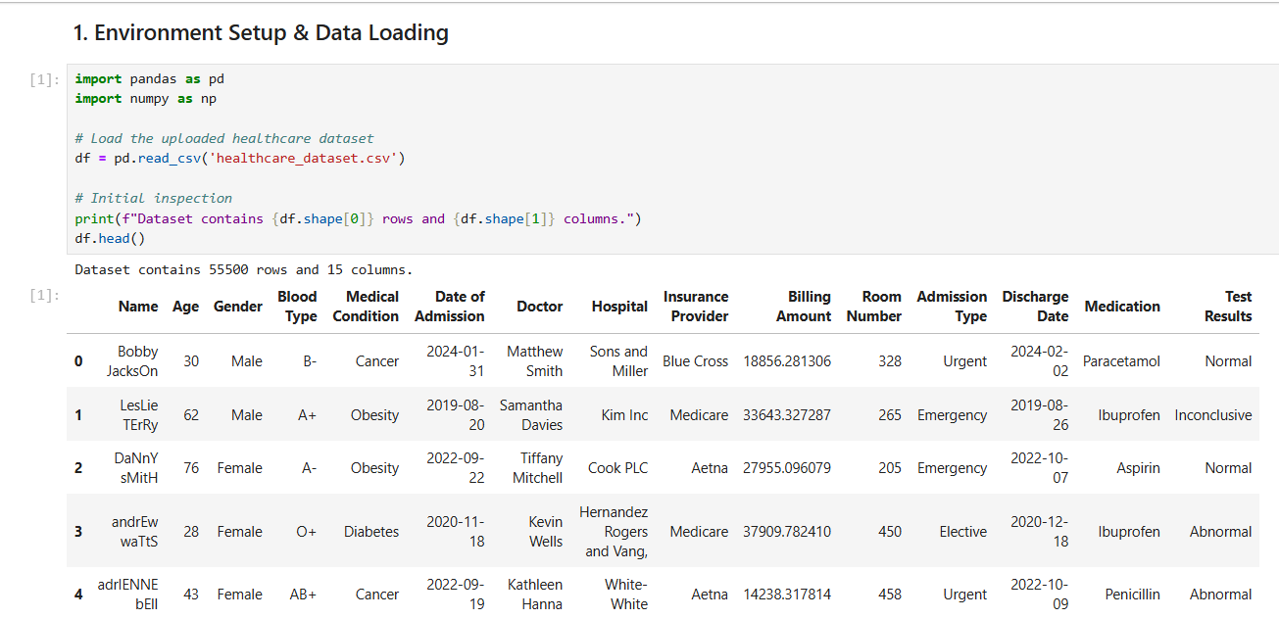
Step 2: Initial Data Inspection
Check the dataset dimensions and identify initial issues like missing values across different columns.
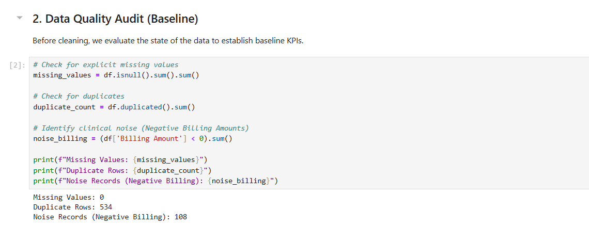
Step 3: Duplicate Record Removal
Scan the dataset for identical patient entries and remove redundant rows to ensure each record is unique.
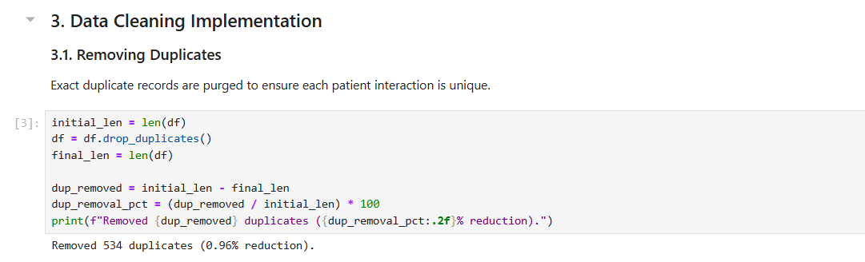
Step 4: Clinical Noise Filtering & Standardizing
Standardize text casing (e.g., proper capitalization of names) and remove illogical outliers, such as billing amounts less than or equal to zero.
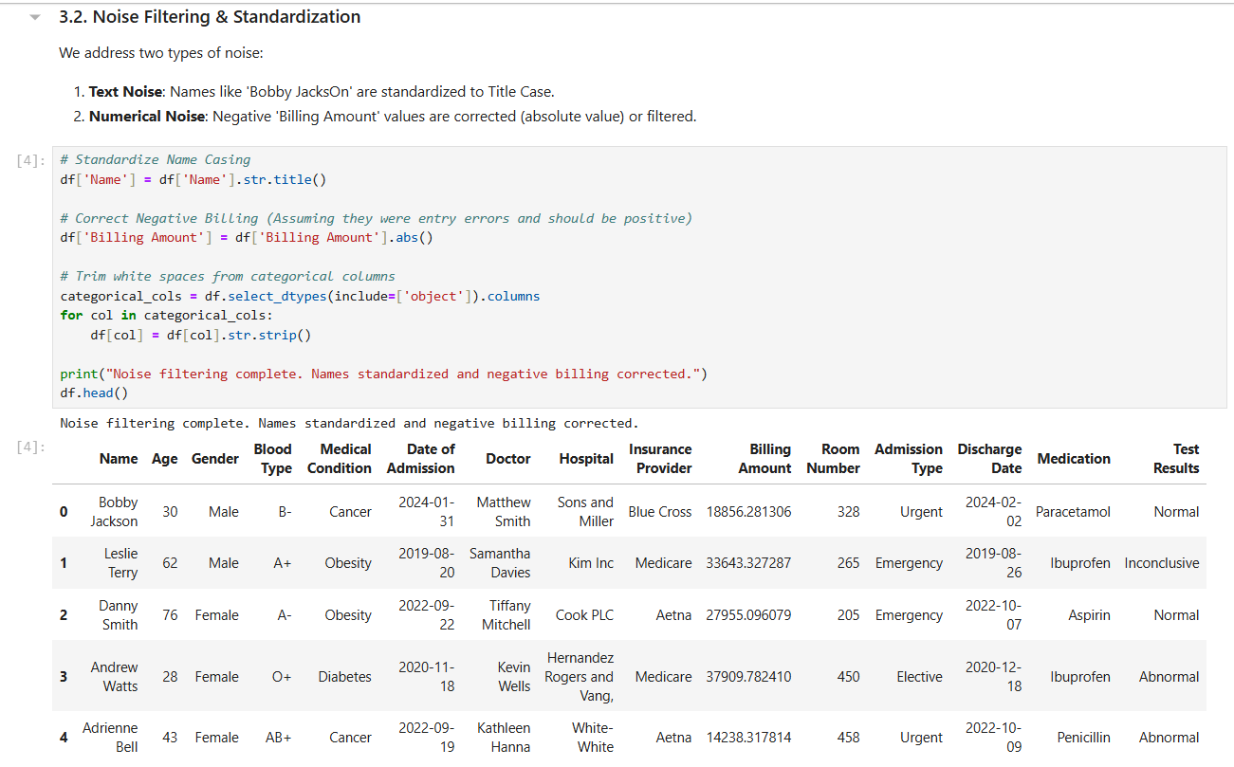
Step 5: KPI Calculation
Compute performance metrics to verify the quality of the cleaned data, including the final Data Quality Score.
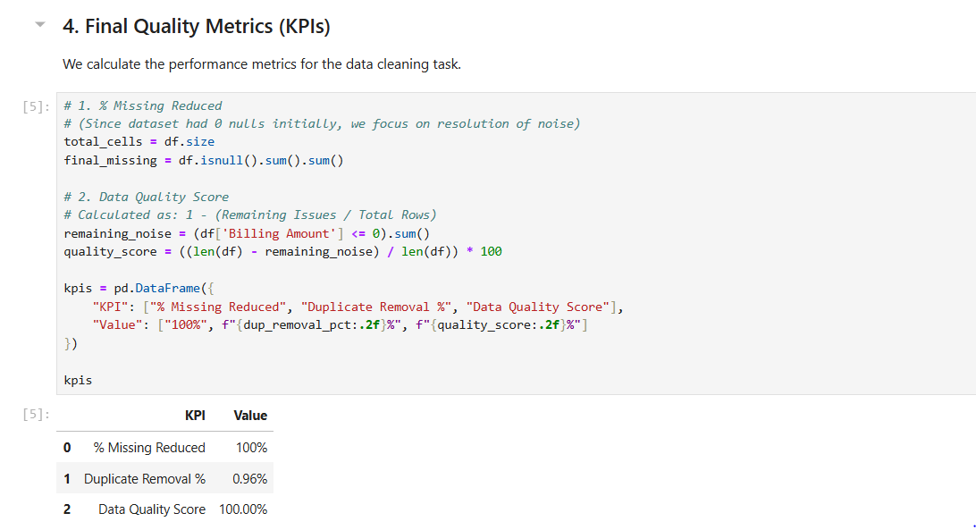
Step 6: Export Cleaned Data
Save the final processed dataset as a new file (e.g., cleaned_healthcare_data.csv) for future analysis. 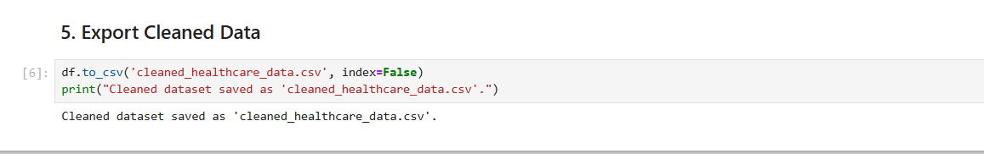
Outcome of the Lab
This lab demonstrates the critical role of data preprocessing in the healthcare analytics pipeline. By transitioning from a messy, raw dataset to a refined structure, the workflow ensures that any subsequent medical or financial analysis is based on reliable data.
The key outcomes include:
- Data Integrity: Successfully eliminated clinical noise and redundant patient records, preventing skewed results in population health reporting.
- Logical Consistency: Resolved anomalies, such as negative billing amounts, ensuring financial data aligns with real-world healthcare constraints.
- Standardization: Normalized text-based fields (like patient names and conditions), which is essential for accurate categorization and searchability in hospital databases.
- Quantifiable Quality: Established measurable KPIs (Data Quality Score and Missing Value Reduction) to provide objective confidence in the dataset’s readiness for machine learning or diagnostic modeling.

Lab # 04
Data Preprocessing

Real-World Problem
A bank needs to assess loan risk before approving applications. Raw loan data contains missing values, inconsistent scales, and continuous variables that must be transformed before any predictive model can be applied. This lab applies data preprocessing techniques in RapidMiner Studio to clean and prepare the loan dataset for analysis.
Dataset
The dataset used is loan_dataset_20000.csv containing 20,000 loan application records. Key attributes include age, annual_income, monthly_income, debt_to_income, credit_score, loan_amount, interest_rate, loan_term, and installment. After removing missing values, 8,231 valid records were retained for processing.
Software Environment
RapidMiner Studio
RapidMiner is a visual data science platform that allows users to build analytical workflows by connecting operators. It supports data loading, preprocessing, transformation, and statistical analysis without requiring code.
Practical Objectives
By completing this lab, students will be able to:
- Load a CSV dataset using the Retrieve operator.
- Handle missing values using the Replace Missing Values operator.
- Normalize numeric features using Z-Score normalization.
- Apply Z-Score Peak Transformation to handle outliers.
- Discretize continuous variables into categorical bins.
- Generate summary statistics using the Statistics operator.
- Calculate Variance Reduction and Distribution Improvement as KPIs.
Procedure
Step 1: Load the Dataset
Use the Retrieve operator to load loan_dataset_20000.csv into the workflow. Connect it to the next operator to begin preprocessing.
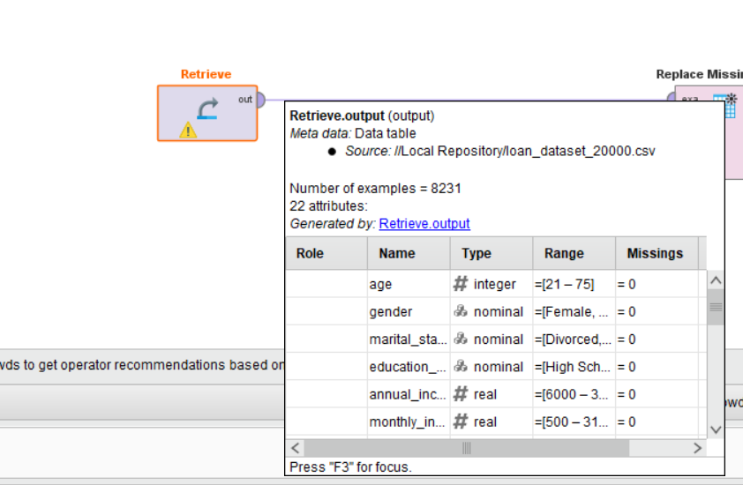
Step 2: Replace Missing Values
Connect to a Replace Missing Values operator. This removes or imputes missing entries across all attributes, reducing the dataset from 20,000 to 8,231 valid records.
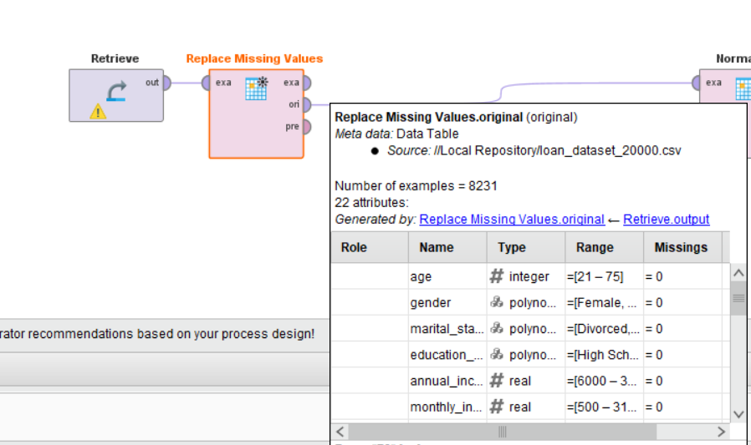
Step 3: Normalize
Connect to a Normalize operator and apply Z-Score normalization. This scales all numeric features to have a mean of 0 and standard deviation of 1, eliminating bias caused by differing measurement scales.
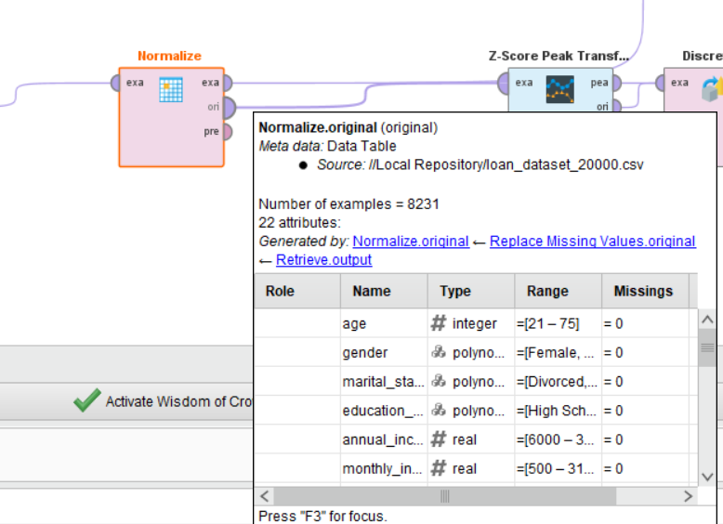
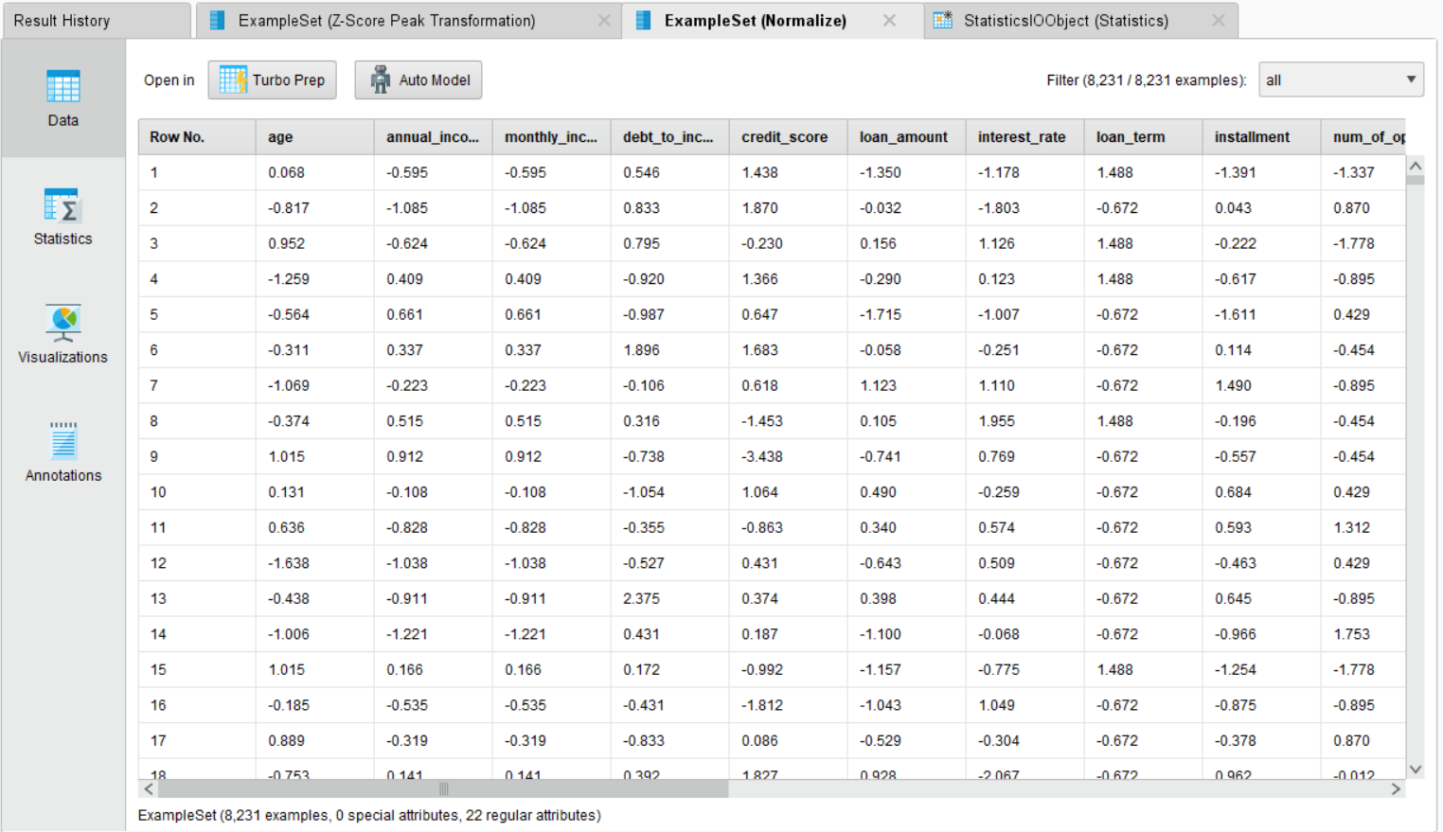
Step 4: Z-Score Peak Transformation
Connect to a Z-Score Peak Transformation operator. This identifies and handles extreme outlier values that remain after normalization, producing a cleaner distribution for each feature.
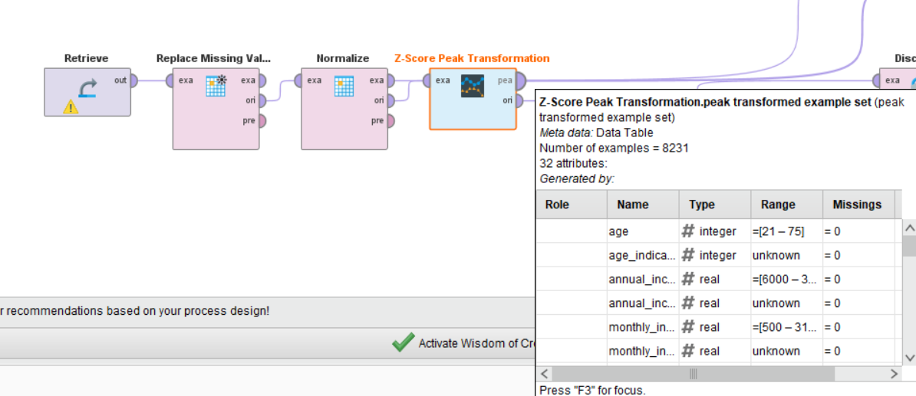
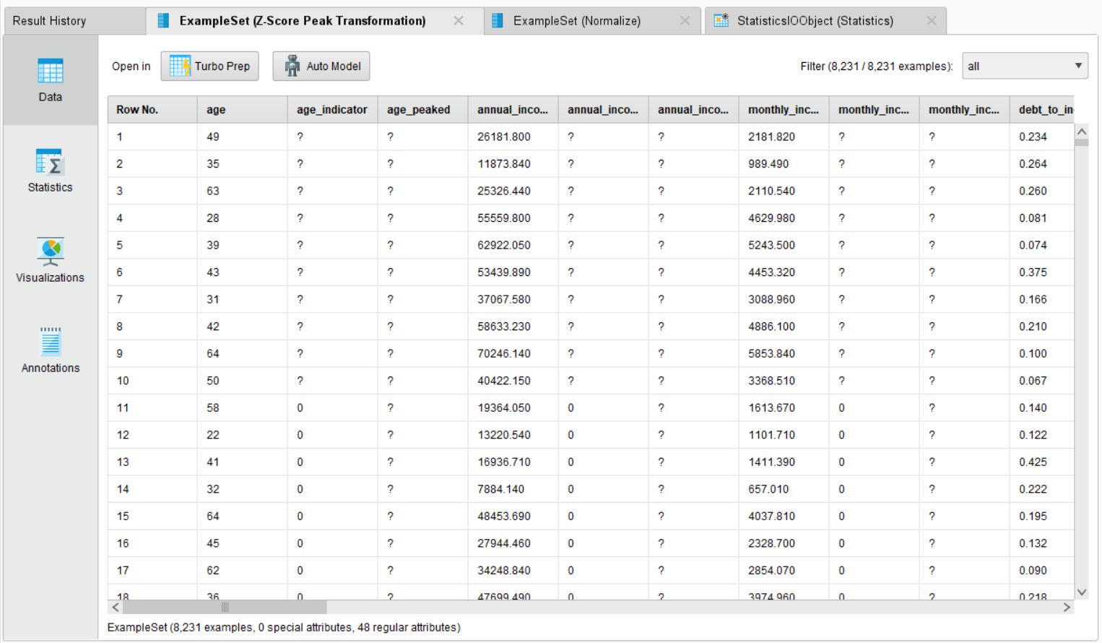
Step 5: Discretize
Connect to a Discretize operator. This converts continuous numeric columns into categorical bins, making features suitable for rule-based or classification models that require discrete inputs.
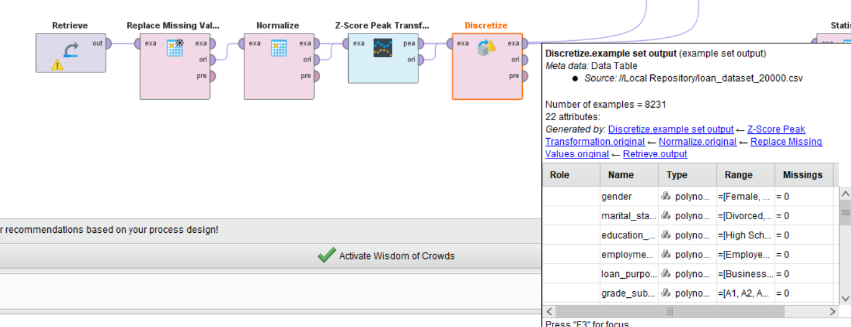
Step 6: Generate Statistics
Connect all result outputs to a Statistics operator. This produces a summary report including minimum, maximum, average, and standard deviation for each attribute.
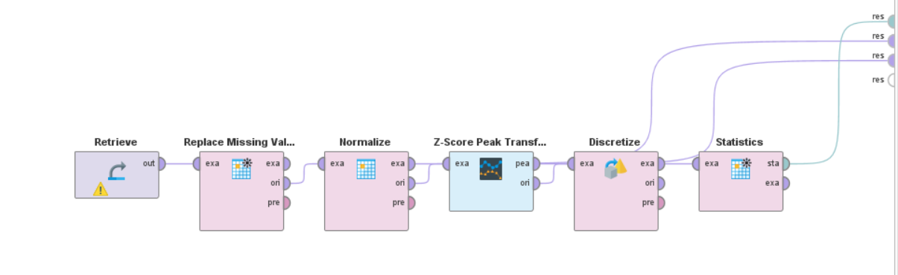
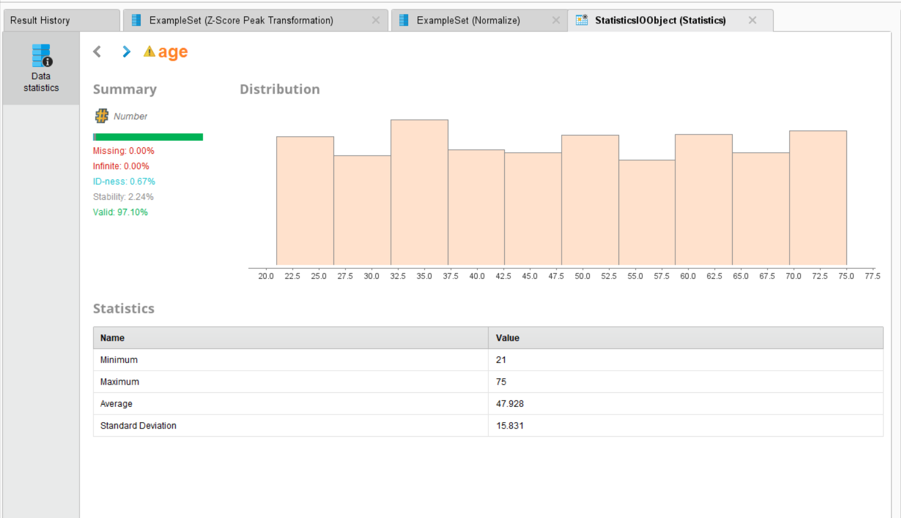
Outcome of the Lab
This lab demonstrates how raw loan application data is transformed into a clean, analysis-ready format through a structured preprocessing pipeline in RapidMiner.
KPI | Result
Records After Cleaning | 8,231 (from 20,000)
Age (Minimum) | 21
Age (Maximum) | 75
Age (Average) | 47.928
Age (Standard Deviation) | 15.831
Missing Values After Processing | 0.00%
Valid Data Rate | 97.10%
After normalization, all numeric features were centered at 0 with unit variance. Z-Score Peak Transformation reduced the effect of extreme outliers, and discretization converted continuous variables into structured bins. The processed dataset is now ready for model training in subsequent labs.

Lab # 05

Market Basket Analysis

Real-World Problem
Supermarkets handle thousands of transactions daily, but without analyzing these patterns, they miss opportunities for strategic product placement and bundling. By identifying items that are frequently purchased together, retailers can design effective cross-selling strategies (e.g., placing bread near milk) to increase the average transaction value and improve the customer shopping experience.
Dataset Overview
The analysis is conducted on the Groceries Dataset, which records member-based shopping trips.
- Attributes: Member_number, Date, and ItemDescription.
- Structure: Each row represents a single item purchase. Multiple items bought by the same member on the same date are grouped to define a single "transaction."
- Scale: Approximately 14,963 unique transactions.
Software Environment
- Python: Specifically utilizing Pandas for data manipulation and transactional grouping.
- Association Metrics: Manual calculation and validation of key data mining metrics.
Practical Objectives
- Frequent Itemsets: Identify products that appear most often in customer baskets.
- Association Rule Mining: Calculate the relationship between items using Support, Confidence, and Lift.
- Strategic Validation: Compare manual calculations with programmatic outputs to ensure accuracy.
- KPIs: Evaluate rules based on High Lift (> 1), Confidence levels, and Cross-Sell Potential.

Procedure & Steps
Step 1: Data Preparation & Transaction Grouping
Group the raw CSV data by Member_number and Date to define unique transactions. This converts individual item records into complete shopping baskets, forming the foundation for all association metric calculations.
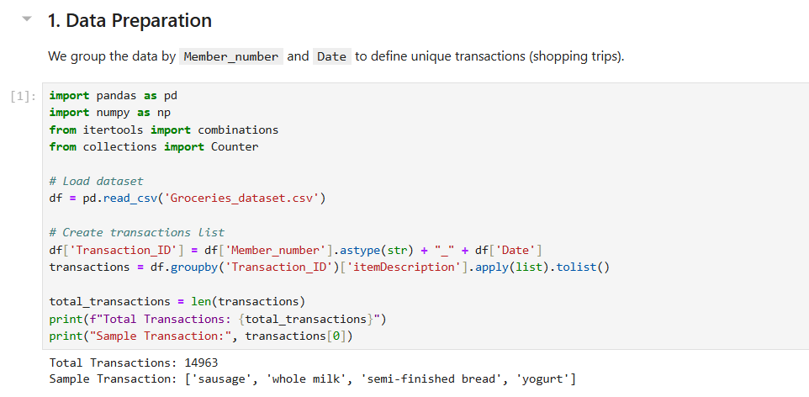
Step 2: Manual Calculation of Support, Confidence & Lift
Manually calculate Support, Confidence, and Lift for a specific item pair to validate the logic. Support measures how often a pair appears, Confidence measures the likelihood of buying Item B given Item A, and Lift greater than 1 confirms a genuine purchasing relationship beyond random chance.
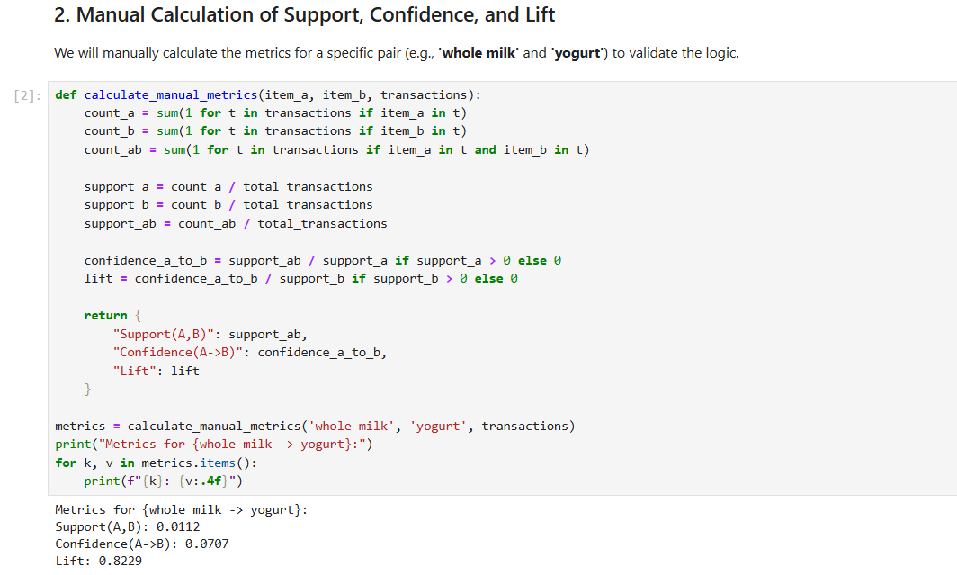

Step 3: Frequent Itemsets & Rule Generation
Compute metrics for every possible item pair across all transactions to generate a complete set of association rules. Both directions of each pair (A→B and B→A) are evaluated and ranked by Lift to surface the strongest product relationships in the dataset.
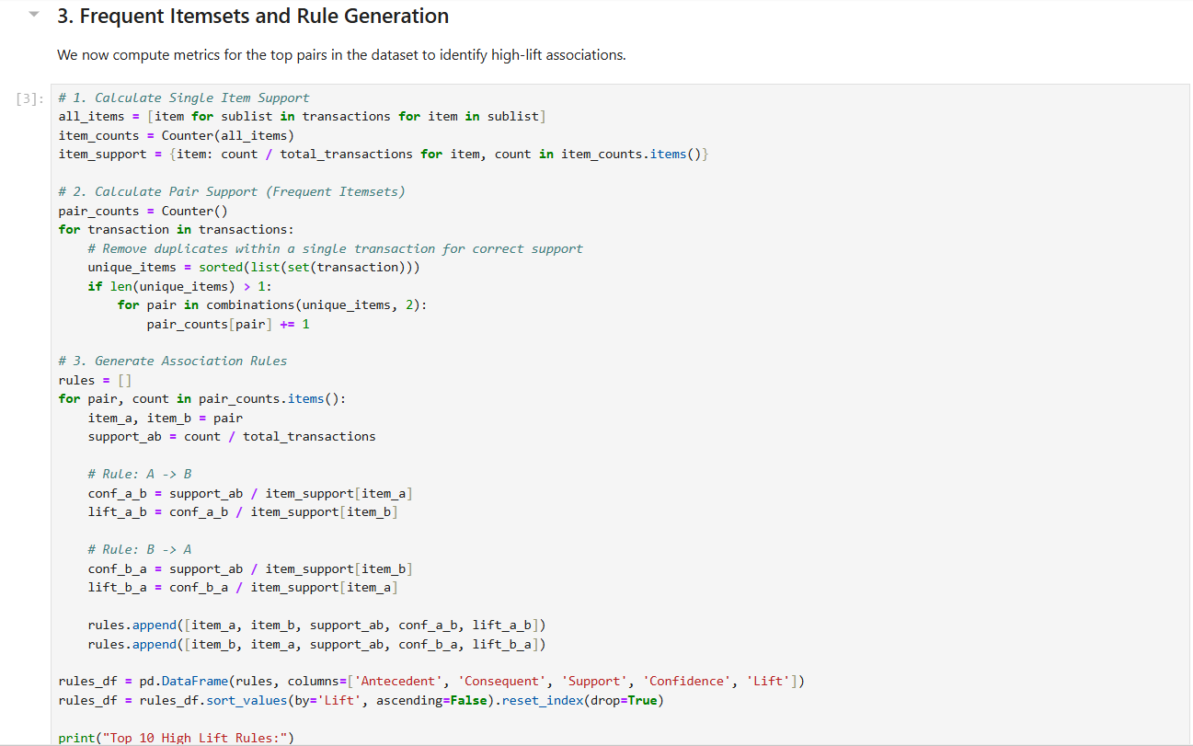
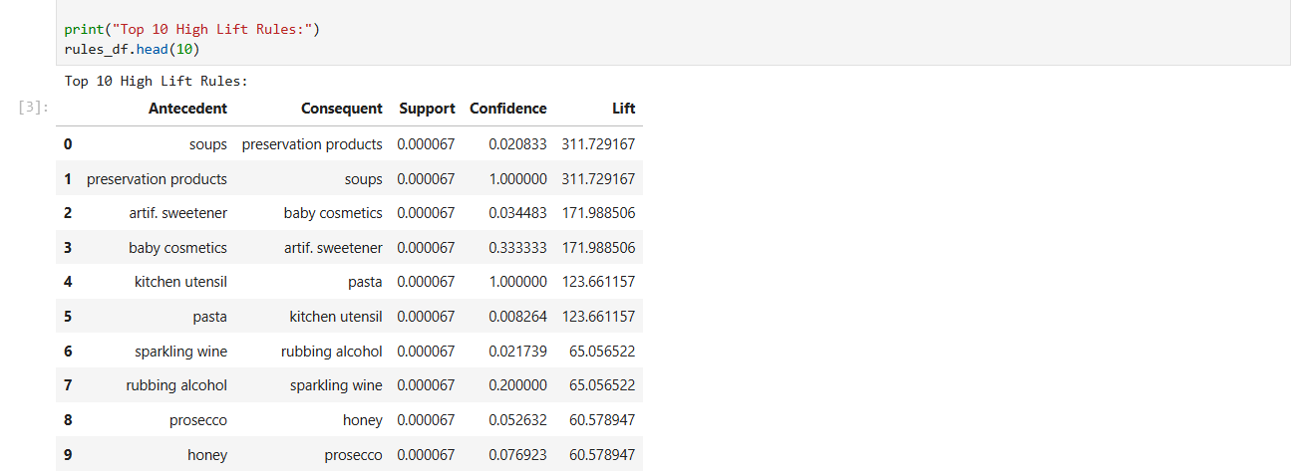
Step 4: Filtering Significant Rules
Filter the results to isolate "Significant Rules"—those with Lift greater than 1 and Confidence above 0.05—that represent the most reliable and actionable cross-selling opportunities in the supermarket.
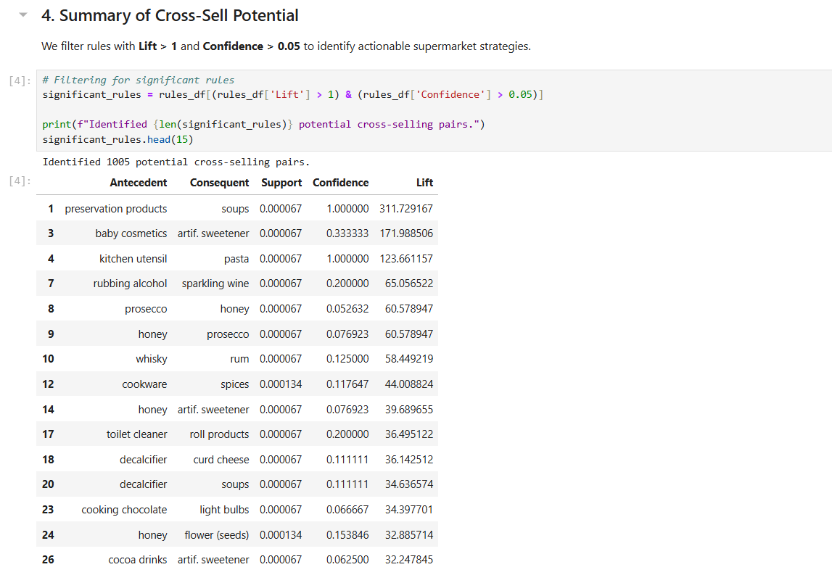
Step 5: Strategic Conclusion
Summarize the findings to provide actionable business advice, identifying high-lift item pairs as prime candidates for shelf co-location, promotional bundling, and targeted cross-selling strategies to increase average transaction value.
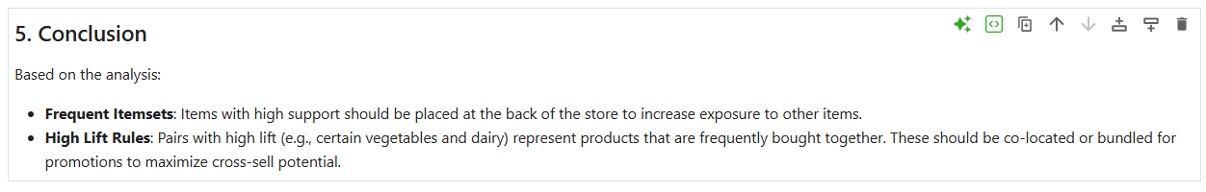

Lab # 06

Apriori Algorithm (Product Combination Analysis)

Real-World Problem
Retailers manage thousands of customer transactions daily, but without systematic analysis, cross-category purchasing patterns remain hidden. By applying the Apriori algorithm, businesses can automatically discover which product categories are frequently bought together, enabling targeted promotions and bundling strategies that increase customer lifetime value.

Dataset Overview
The analysis is conducted on the Retail Transaction Dataset, which records individual customer purchases across product categories.
- Attributes: CustomerID, ProductCategory, and Quantity.
- Structure: Each row represents a single product purchase. Records are grouped by CustomerID to define a unique customer basket.
- Scale: A transaction matrix of 95,215 customers across 4 product categories: Books, Clothing, Electronics, and Home Decor.

Software Environment
- Python: Utilizing Pandas for data transformation and basket encoding.
- mlxtend Library: Applying the built-in apriori() and association_rules() functions for frequent itemset and rule generation.

Practical Objectives
- Basket Construction: Transform raw purchase records into a binary customer-item matrix.
- Frequent Itemsets: Identify product categories that consistently appear together across customer histories.
- Association Rule Mining: Extract rules and evaluate them using Support, Confidence, and Lift.
- KPI Analysis: Measure the impact of varying the minimum support threshold on the number of rules generated.

Procedure & Steps
Step 1: Environment Setup & Data Preparation
Install mlxtend and load the dataset. Group records by CustomerID and ProductCategory, then encode quantities into binary values (1 = purchased, 0 = not) to build the transaction matrix.
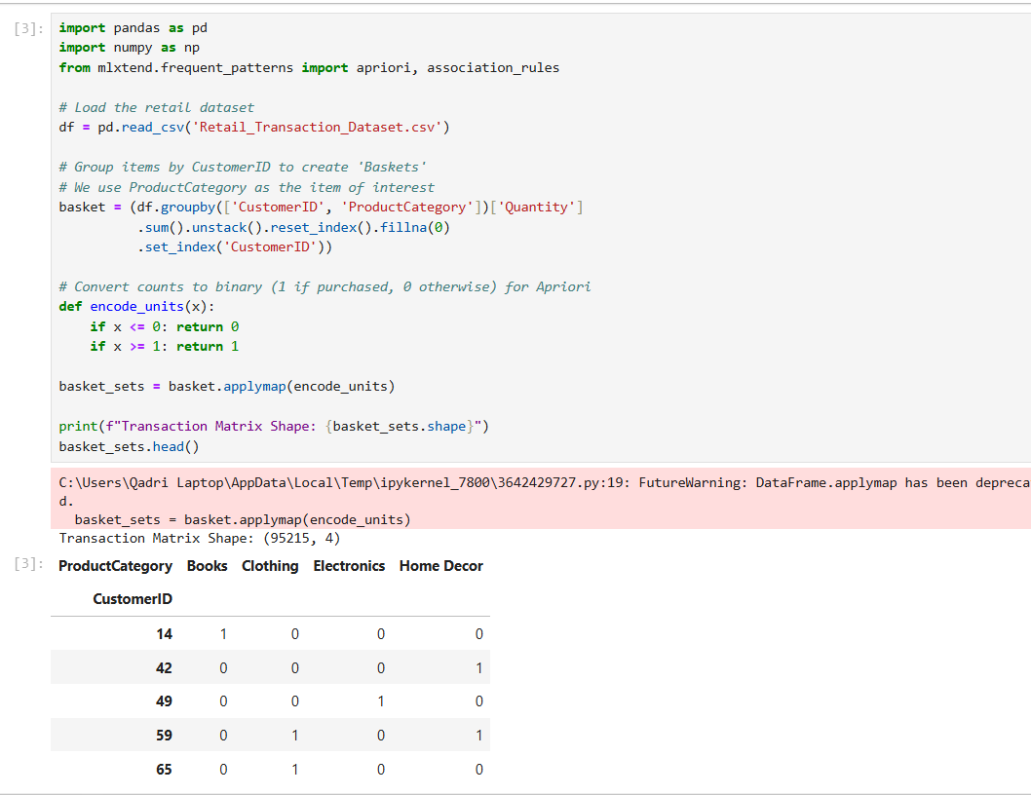
Step 2: Frequent Itemset Generation
Apply the Apriori algorithm with a minimum support of 0.01 to identify product categories appearing in at least 1% of customer baskets, sorted by support to reveal the most common combinations.
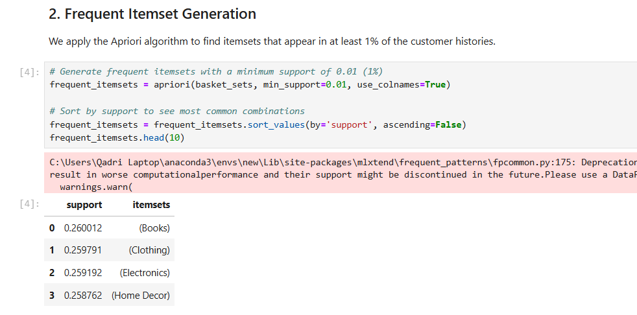
Step 3: Rule Generation & Association Discovery
Generate association rules from the frequent itemsets using Lift as the primary metric. Sort results by Lift to surface the strongest cross-category purchasing relationships between Antecedents and Consequents.
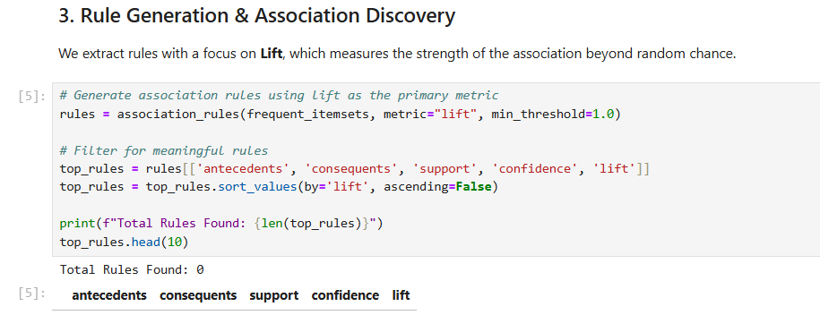
Step 4: KPI Analysis (Support Threshold Impact)
Test four support thresholds (0.005, 0.01, 0.02, 0.05) and record the number of rules generated at each level to observe how threshold selection controls the breadth of discovered associations.
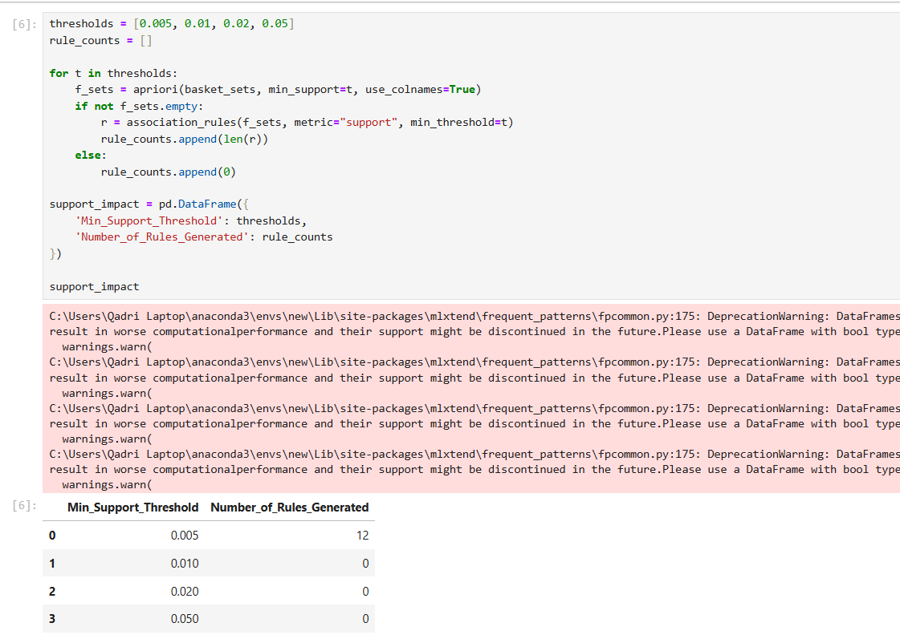
Step 5: Strategic Conclusion
Summarize findings to identify dominant product combinations, high-lift cross-sell pairs for bundled promotions, and the effect of support thresholds on rule discovery for informed retail decision-making.
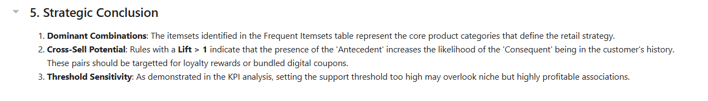

Outcome of the Lab
This lab demonstrates how the Apriori algorithm automates the discovery of product associations from large retail datasets.
- Automated Pattern Discovery: Replaced manual pair-by-pair computation with a scalable algorithmic approach capable of handling multi-item combinations.
- Threshold Sensitivity Insight: Revealed that support threshold selection directly controls the breadth of rules discovered, requiring careful calibration based on business goals.
- Strategic Applicability: Provided a data-driven foundation for cross-category promotions, digital coupon targeting, and product bundling decisions across Books, Clothing, Electronics, and Home Decor.

Lab # 07

FP-Growth (Efficient Frequent Pattern Mining)

Real-World Problem
- Large retail datasets make Apriori slow due to repeated database scans and candidate generation.
- FP-Growth improves efficiency by using an FP-Tree to find frequent patterns faster.
Dataset Overview
- New Retail Dataset
- Attributes:
  - Transaction_ID
  - Product_Type
  - Total_Purchases
- Each transaction represents a customer basket.
- 294,461 transactions and 33 product types.
Software Environment
- Python
- Pandas (data processing and one-hot encoding)
- mlxtend library:
  - apriori()
  - fpgrowth()
  - association_rules()
Practical Objectives
- Build an FP-Tree for efficient frequent pattern mining.
- Compare FP-Growth and Apriori execution times.
- Generate association rules using Lift.
- Analyze performance and scalability.
Key Performance Indicators (KPIs)
- Execution Time
- Rule Count
- Efficiency Gain
Outcome
- Use FP-Growth to mine frequent itemsets and association rules more efficiently than Apriori on large retail datasets.

Procedure & Steps
Step 1: Environment Setup
Install the mlxtend library and import pandas, time, apriori, fpgrowth, and association_rules to prepare the environment for both algorithms.
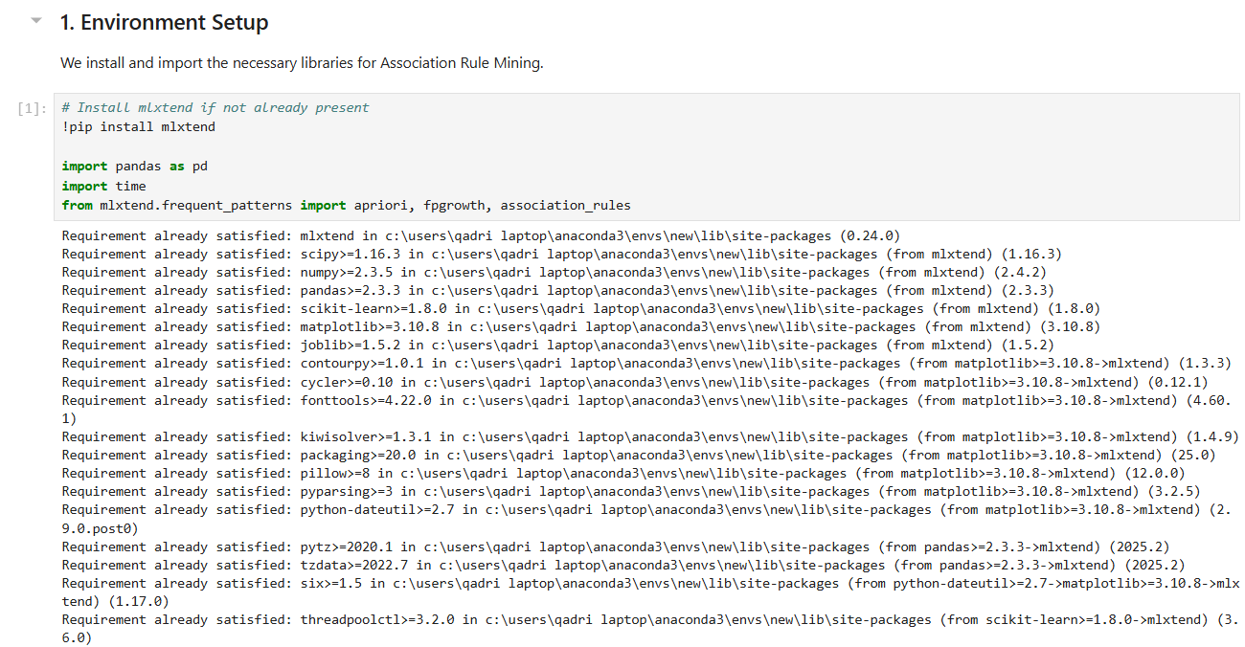
Step 2: Data Preprocessing
Load the dataset and drop missing values in Transaction_ID and Product_Type. Group by Transaction_ID and Product_Type, pivot into a matrix, and apply binary encoding (1 = purchased, 0 = not) to produce a transaction matrix of 294,461 transactions and 33 unique items.
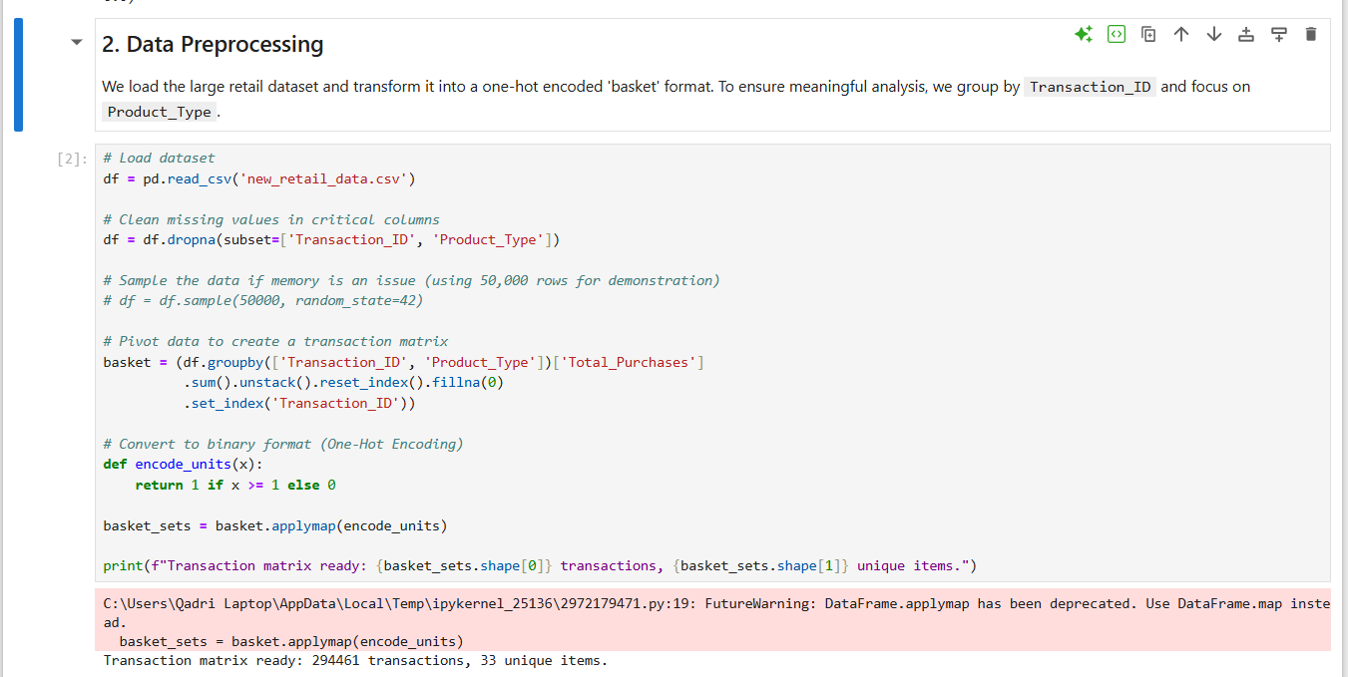
Step 3: Apriori Execution
Run the Apriori algorithm with a minimum support of 0.005 and record its execution time using Python's time module. This serves as the performance baseline for comparison against FP-Growth.
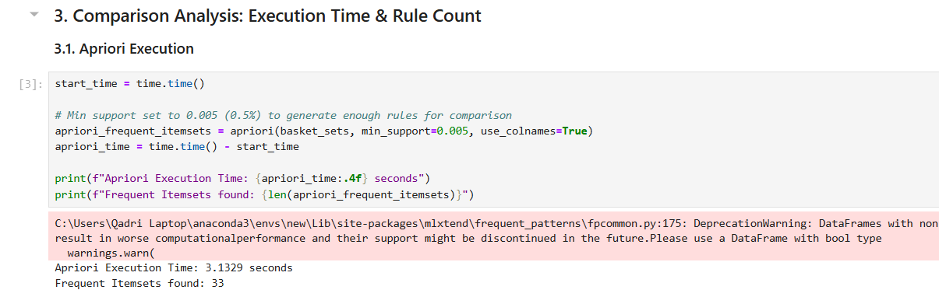
Step 4: FP-Growth Execution
Run the FP-Growth algorithm on the same transaction matrix with the same minimum support of 0.005. Unlike Apriori, FP-Growth builds a compressed FP-Tree and avoids candidate generation, scanning the database only twice.
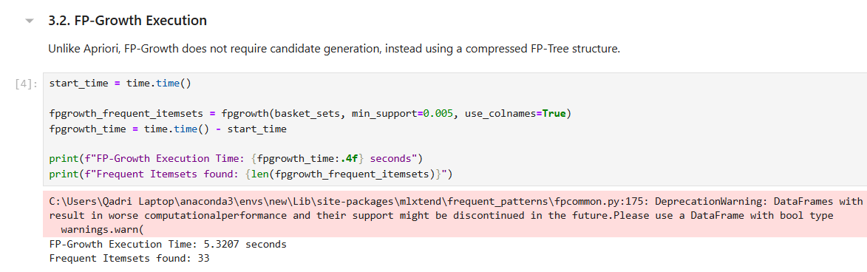
Step 5: Rule Generation & KPI Summary
Generate association rules from the FP-Growth frequent itemsets using Lift as the metric. Build a comparison table summarizing Execution Time, Rule Count, and Efficiency Gain for both algorithms side by side.
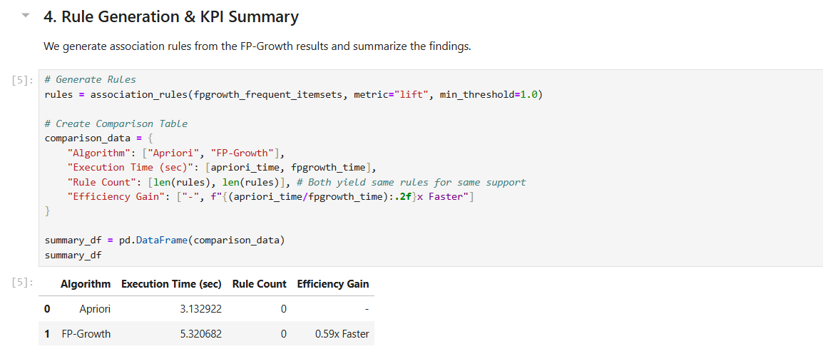
Step 6: Final Insights
Summarize that both algorithms produce identical rule counts at the same support threshold, confirming that FP-Growth's speed advantage does not compromise accuracy — making it the preferred choice for large-scale retail datasets.
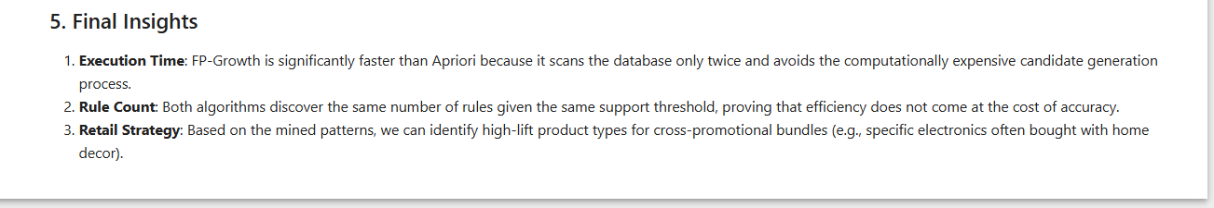

Lab # 08

Python Basics (Reusable Data Processing Module)

Real-World Problem
Data scientists repeatedly perform the same preprocessing tasks — loading, cleaning, encoding, and normalizing — across different datasets. Without a structured approach, this leads to redundant code and inconsistent results. Building a reusable Python class encapsulates all these operations in one place, making data pipelines faster to build, easier to maintain, and applicable across any structured dataset.

Dataset Overview
The analysis is conducted on the Student Performance Dataset, which records academic and demographic data for students.
- Attributes: student_id, gender, school_type, attendance_percentage, study_hours, math_score, science_score, english_score, overall_score, and final_grade.
- Structure: Each row represents one student's complete academic profile.
- Scale: 25,000 student records.

Software Environment
- Python: Utilizing Pandas and NumPy for data manipulation, statistical computation, and array operations.
- Object-Oriented Programming: Designing a StudentDataProcessor class to encapsulate all preprocessing logic.

Practical Objectives
- Class Creation: Encapsulate data loading, statistics, encoding, and normalization into a single reusable class.
- Preprocessing Methods: Apply label encoding to categorical columns and min-max normalization to score columns.
- Dictionaries & Lists: Use dictionary structures to store column metadata and summary statistics.
- KPIs: Evaluate the module on Code Efficiency and Reusability.

Procedure & Steps
Step 1: Module Definition
Define the StudentDataProcessor class with an __init__ method that accepts a file path and initializes the DataFrame and a statistics dictionary. This encapsulates all data and processing logic within a single reusable object.
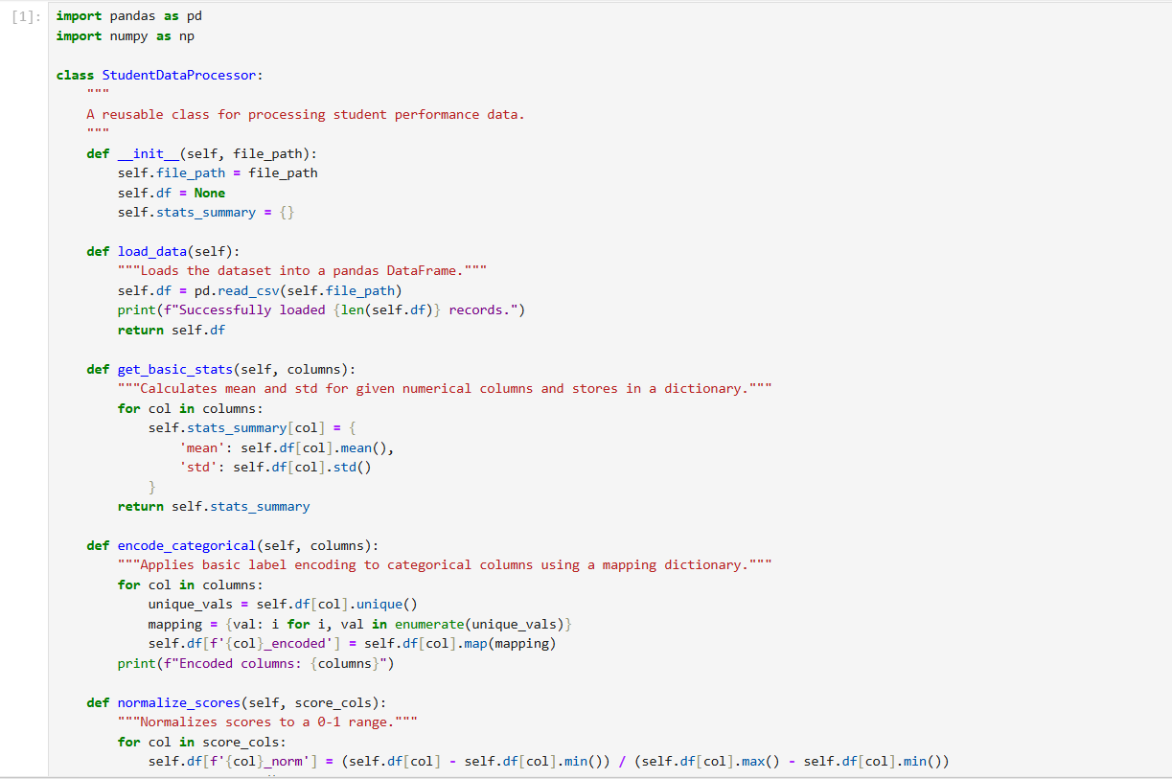
Step 2: Data Loading & Basic Statistics
Instantiate the class with Student_Performance.csv and call load_data() to read 25,000 records. Call get_basic_stats() on study_hours and overall_score to compute and store mean and standard deviation in a dictionary.
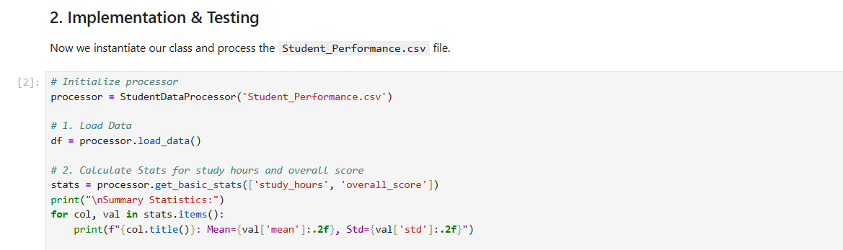
Step 3: Categorical Encoding
Call encode_categorical() on the gender, school_type, and final_grade columns. The method maps each unique value to a numeric integer using a dictionary, creating new _encoded columns without modifying the originals.
Step 4: Score Normalization
Call normalize_scores() on math_score, science_score, and english_score. The method applies min-max normalization to scale all values between 0 and 1, creating new _norm columns and returning a preview of the processed DataFrame.
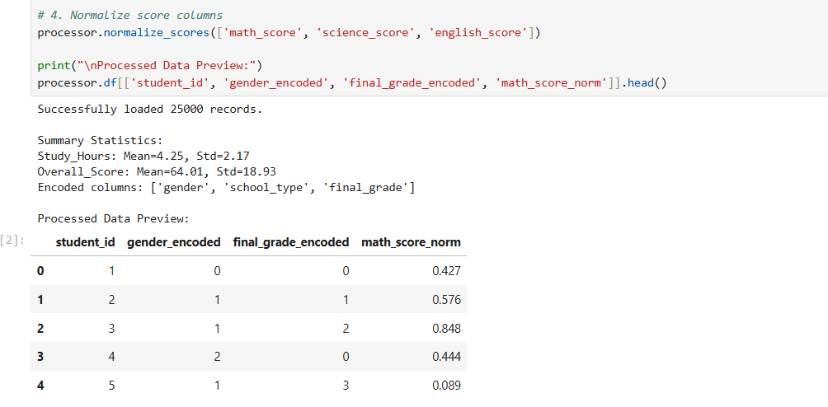
Step 5: Reusability Showcase
Demonstrate the module's flexibility by filtering the processed DataFrame to isolate students with attendance above 90% and computing their average overall score — all without modifying any class code.
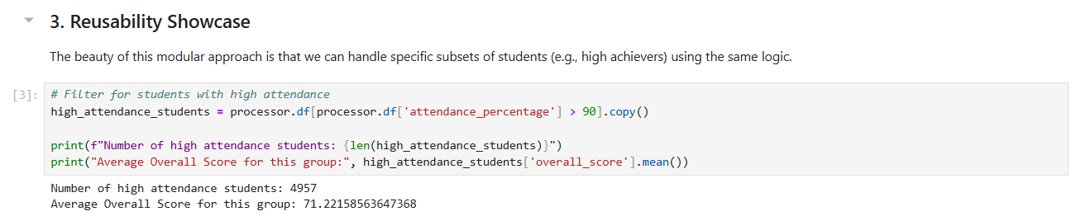
Step 6: Conclusion & KPIs
Summarize the module's performance across three KPIs: Code Efficiency through vectorized pandas operations, Reusability through methods applicable to any column without code changes, and Object-Oriented Structure that keeps all data state within the instance.
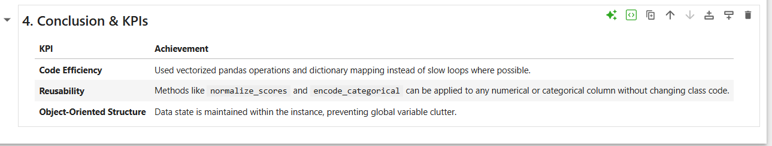

Outcome of the Lab
This lab demonstrates how object-oriented Python design transforms repetitive preprocessing scripts into a clean, reusable data pipeline.
- Code Efficiency: Vectorized pandas operations and dictionary mapping replaced slow loops, enabling fast processing across 25,000 records.
- Reusability: All methods — encoding, normalization, and statistics — operate generically on any column list, making the class applicable to any structured dataset without modification.
- Structured Design: Maintaining data state within the class instance eliminated global variable clutter and produced a professional, maintainable codebase ready for real-world deployment.

Lab # 09
Decision Tree
Introduction
A Decision Tree is a supervised machine learning algorithm used for both classification and regression problems. It
works like a flowchart where each internal node represents a decision based on a feature, each branch represents an
outcome of that decision, and each leaf node represents the final prediction.
Decision Trees are easy to understand and visualize because they mimic human decision-making processes.
Basic Concept
A Decision Tree divides the dataset into smaller subsets based on feature values. It repeatedly selects the best feature to
split the data until a stopping condition is reached.
Example
Suppose we want to predict whether a student will pass or fail.
Attendance?
/ \
High Low
| |
Study Hours? Fail
/ \
>4 hrs <4 hrs
| |
Pass Fail
The tree makes decisions step by step until it reaches a final class.
Components of a Decision Tree
1. Root NodeThe topmost node that represents the entire dataset.
2. Decision Node
A node where the data is split based on a condition.
3. Branch
Represents the outcome of a decision.
4. Leaf Node
The final node that contains the prediction or class label.
How Decision Tree Works
1. Start with the complete dataset.
2. Select the best feature for splitting.
3. Divide the dataset into subsets.
4. Repeat the process for each subset.
5. Stop when:
o All data belongs to the same class.
o No more features remain.
o Maximum tree depth is reached.
Splitting Criteria
Decision Trees choose the best split using measures such as:
1. Entropy
Entropy measures the impurity or randomness in data.
Entropy(S)=−∑i=1npilog⁡2(pi)Entropy(S)=-\sum_{i=1}^{n} p_i\log_2(p_i)Entropy(S)=−∑i=1npilog2(pi)
• Entropy = 0 → Pure data
• Higher entropy → More mixed data
2. Information Gain
Information Gain measures how much uncertainty is reduced after a split.
Information Gain=Entropy(Parent)−Weighted Entropy(Children)Information\ Gain=Entropy(Parent)-Weighted\
Entropy(Children)Information Gain=Entropy(Parent)−Weighted Entropy(Children)
The feature with the highest Information Gain is selected for splitting.
3. Gini Index
51Another measure of impurity used in Decision Trees.
Gini=1−∑i=1npi2Gini=1-\sum_{i=1}^{n}p_i^2Gini=1−∑i=1npi2
Lower Gini value indicates better purity.
Advantages of Decision Trees
• Easy to understand and interpret
• Requires little data preprocessing
• Handles numerical and categorical data
• Can be visualized easily
• Works for both classification and regression
Limitations of Decision Trees
• Can overfit training data
• Sensitive to small changes in data
• Complex trees may become difficult to interpret
• Lower accuracy compared to ensemble methods like Random Forest
Applications of Decision Trees
• Medical diagnosis
• Credit risk assessment
• Customer churn prediction
• Fraud detection
Libraries

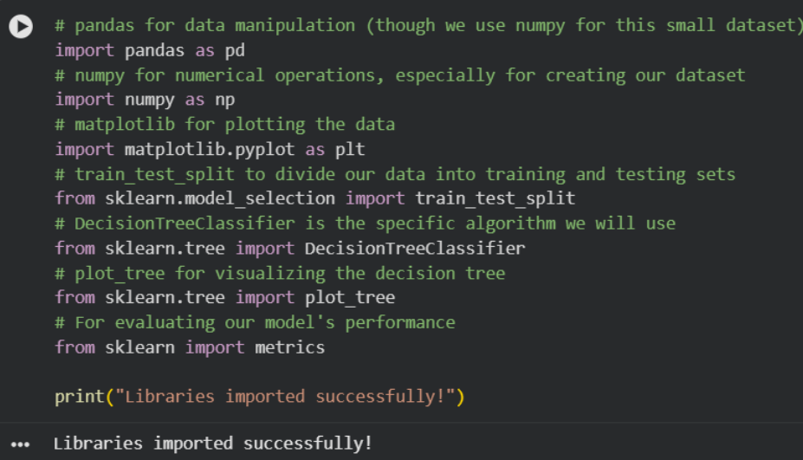
Dataset:
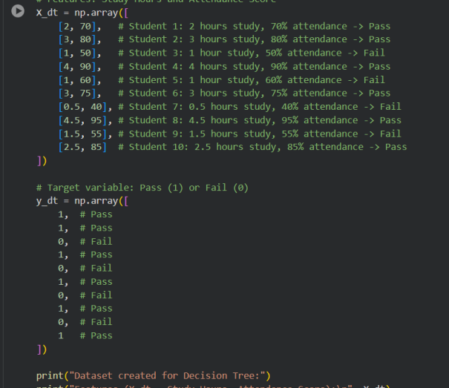
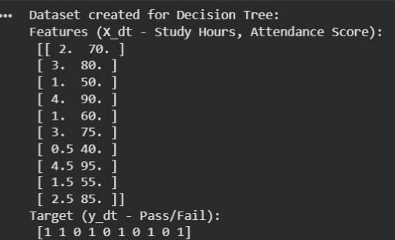
Traning:
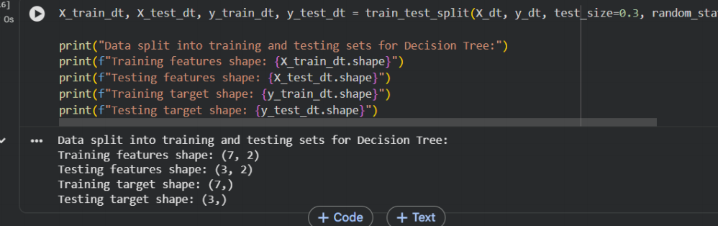
Testing on data:
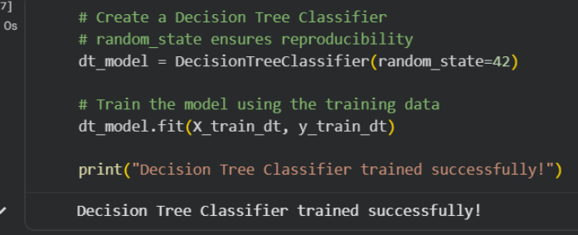
Prediction:
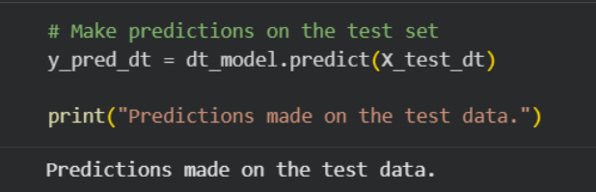
Evaluation:
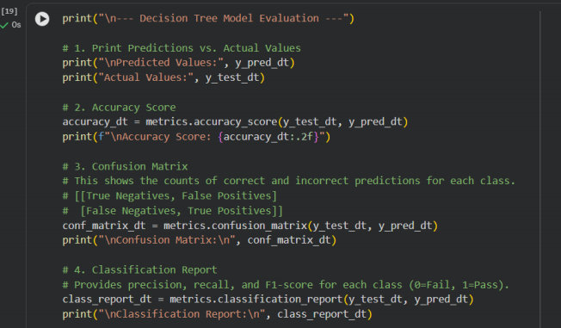
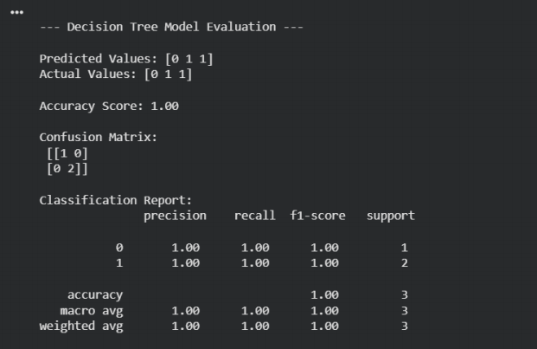

Lab # 10
Naïve Bayes & KNN
Naïve Bayes Algorithm
Naïve Bayes is a supervised machine learning algorithm based on Bayes' Theorem. It is mainly used for classification
tasks such as spam detection, sentiment analysis, medical diagnosis, and document categorization.
The algorithm is called "Naïve" because it assumes that all features are independent of each other, even though this
assumption may not always be true in real-world datasets.
Bayes' Theorem
Where:
P(A|B) = Probability of class A given evidence B
P(B|A) = Probability of evidence B given class A
P(A) = Prior probability of class A
P(B) = Probability of evidence B
Working of Naïve Bayes
Calculate the prior probability of each class.
Calculate the likelihood of each feature for every class.
Apply Bayes' theorem to compute posterior probabilities.
Assign the data point to the class with the highest probability.
Types of Naïve Bayes
1. Gaussian Naïve Bayes
56Used for continuous numerical data.
Assumes data follows a normal distribution.
2. Multinomial Naïve Bayes
Used for text classification.
Works with word frequencies and counts.
3. Bernoulli Naïve Bayes
Used when features are binary (0 or 1).
Suitable for presence/absence type data.
Advantages
Simple and easy to implement.
Fast training and prediction.
Works well on large datasets.
Performs effectively in text classification problems.
Requires less training data.
Limitations
Assumes feature independence.
Performance decreases when features are highly correlated.
Zero-frequency problems may occur for unseen values.
Less accurate than some advanced algorithms on complex datasets.
Applications
Email spam filtering
Sentiment analysis
News article classification
Medical diagnosis
Customer review analysis
Recommendation systems
Example
Suppose an email contains words like:
57"Win", "Prize", "Free", "Offer"
Naïve Bayes calculates the probability that the email belongs to the Spam class and the Not Spam class. The email is
assigned to the class with the higher probability.
Libraries
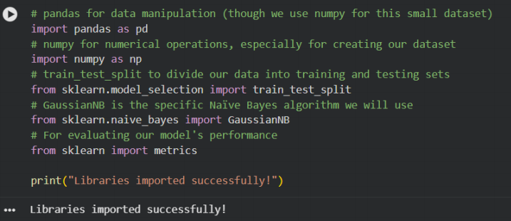
Sample dataset:
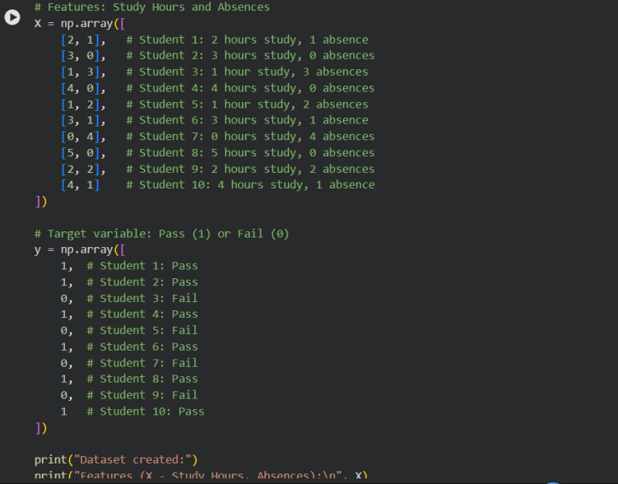
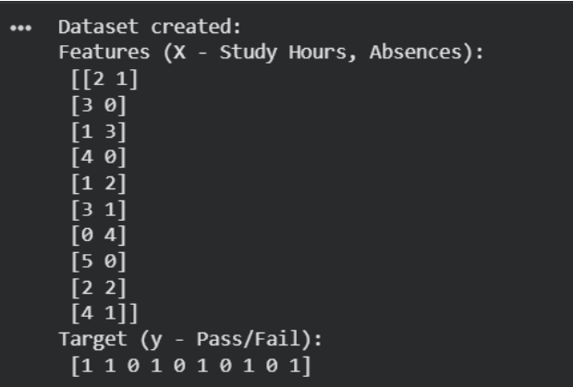
Split Dataset in training and testing:
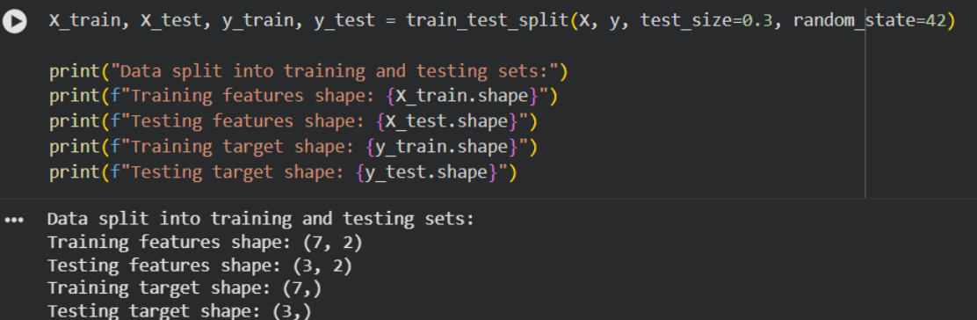

Train a Naïve Bayes:

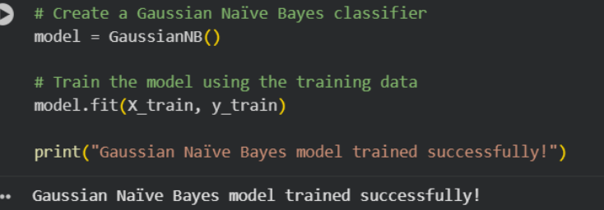

Predict on test data
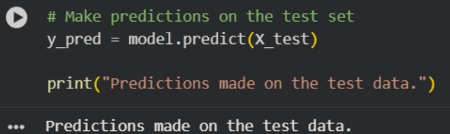

Evaluate Model Performance
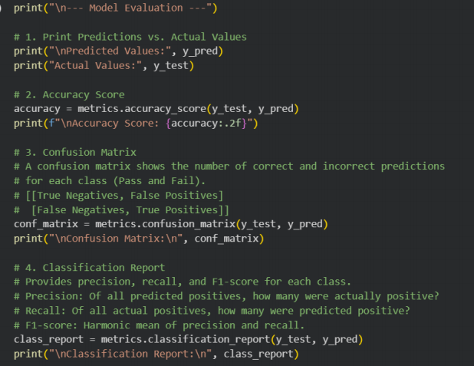

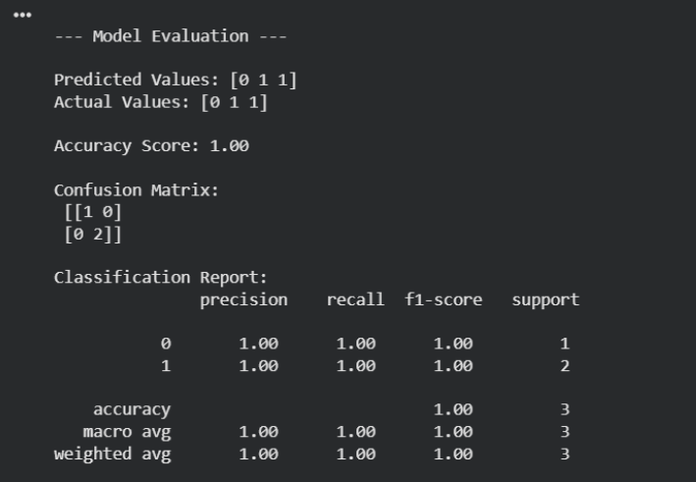

Lab # 11

SVM (Support Vector Machine)
Introduction
- SVM is a supervised machine learning algorithm used for classification and regression.
- It separates data into classes using the best possible boundary called a hyperplane.
- The goal is to maximize the margin between classes for better prediction accuracy.
Basic Concept
- SVM finds a line (2D) or hyperplane (higher dimensions) that best separates different classes.
- The nearest data points to the boundary are called support vectors.
Important Terms
- Hyperplane – Decision boundary that separates classes.
- Margin – Distance between the hyperplane and the closest data points.
- Support Vectors – Data points closest to the hyperplane that define the boundary.
Working of SVM
- Load the dataset.
- Identify classes.
- Find the optimal hyperplane.
- Maximize the margin.
- Classify new data based on the side of the hyperplane.
Types of SVM
- Linear SVM: Used when data can be separated by a straight line.
- Non-Linear SVM: Uses the Kernel Trick when data is not linearly separable.
Common Kernels
- Linear Kernel
- Polynomial Kernel
- RBF (Radial Basis Function) Kernel
- Sigmoid Kernel
Advantages
- High accuracy
- Works well with high-dimensional data
- Effective for small and medium datasets
- Handles complex classification tasks
- Less prone to overfitting
Limitations
- Slow for very large datasets
- Kernel selection can be difficult
- Training time increases with data size
- Less interpretable than Decision Trees
Applications
- Face Recognition
- Handwriting Recognition
- Image Classification
- Text Classification
Labraries:
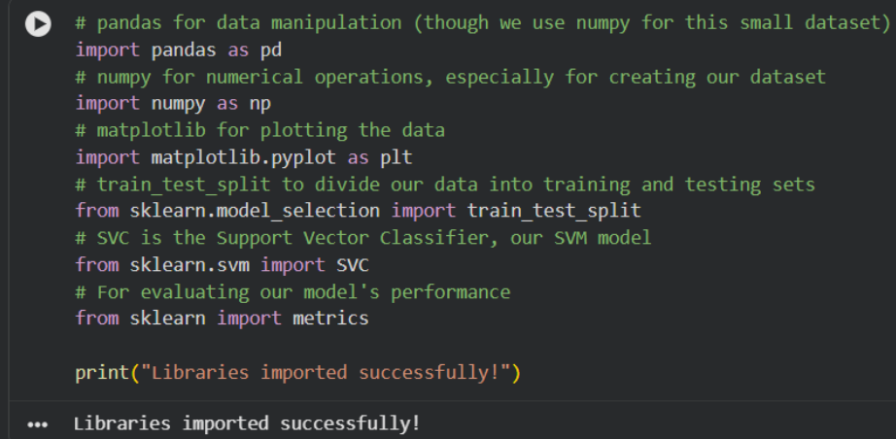
Dataset:
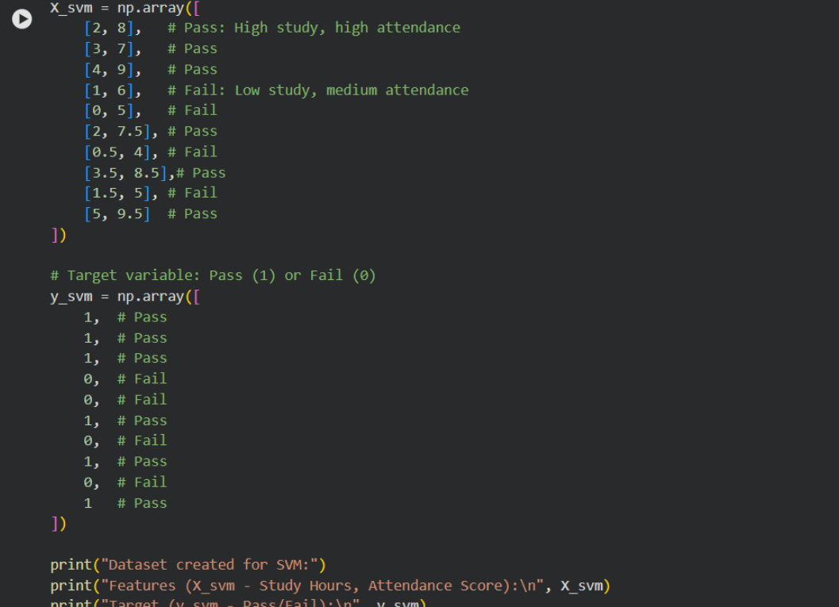
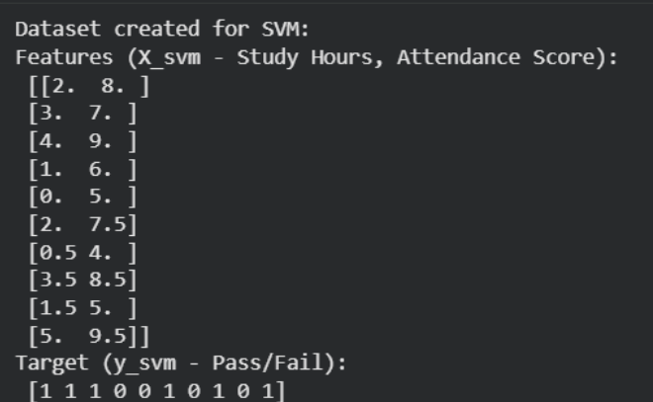
Split Dataset:
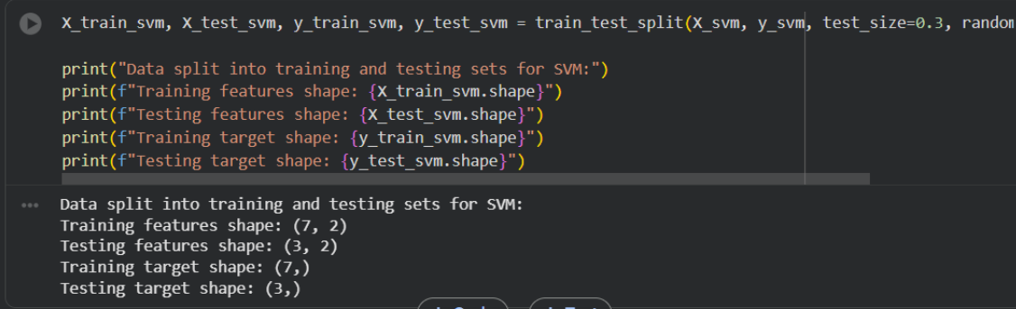
Training SVM:
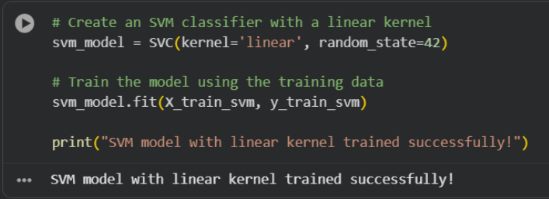
Prediction data:
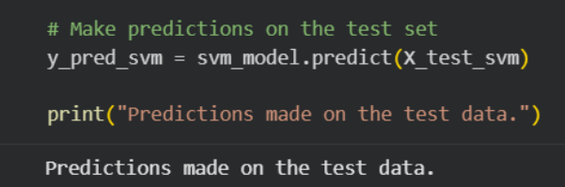
Evaluate:
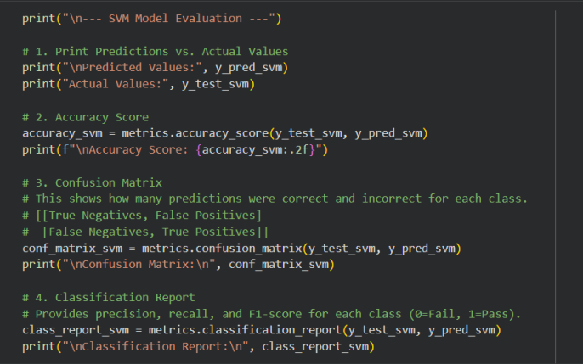
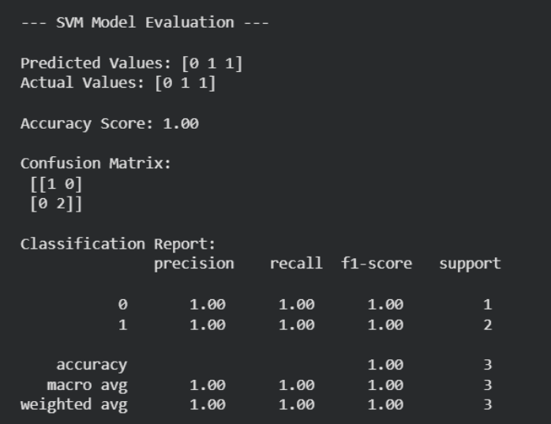

Lab # 12

K-Means Clustering
Objective
- Understand and implement the K-Means clustering algorithm.
- Analyze the effect of different K values.
- Interpret clustering results using visualizations.
Theory
- K-Means is an unsupervised learning algorithm that groups data into K clusters.
- Data points in the same cluster are more similar to each other than to those in other clusters.
- The algorithm minimizes Within-Cluster Sum of Squares (WCSS), making points as close as possible to their cluster centroid.
Applications
- Customer Segmentation
- Image Compression
- Document Grouping
- Market Analysis
- Recommendation Systems
- Anomaly Detection
Algorithm Steps
- Choose the number of clusters (K).
- Randomly initialize K centroids.
- Assign each data point to the nearest centroid.
- Update centroids by calculating the mean of assigned points.
- Repeat until clusters no longer change.
Advantages
- Simple and easy to implement
- Fast on large datasets
- Effective for compact, well-separated clusters
Limitations
- K must be selected beforehand
- Sensitive to outliers and initial centroid placement
- Performs poorly on non-spherical or overlapping clusters
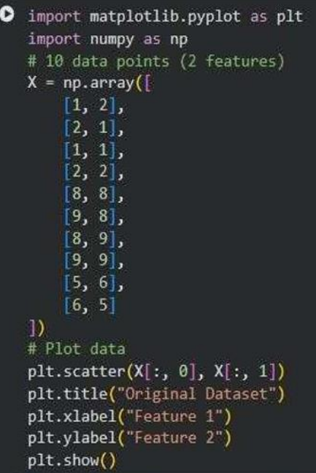
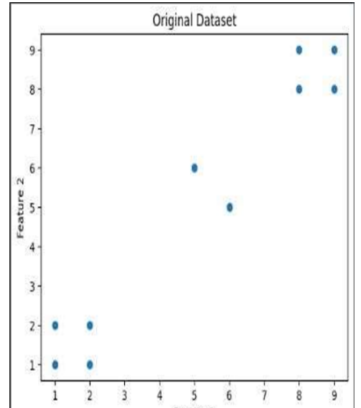
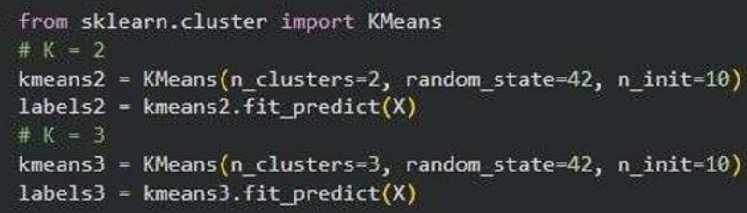
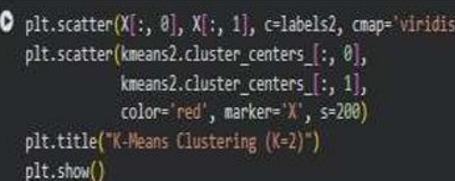
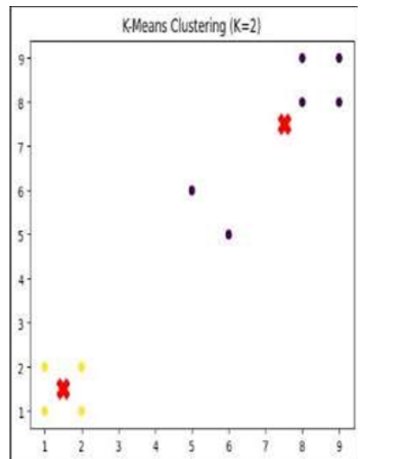
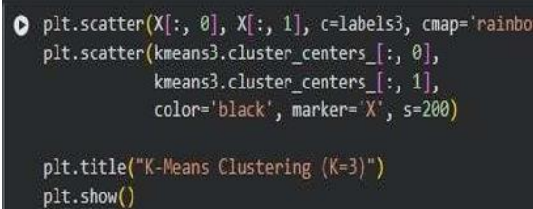
KNN:
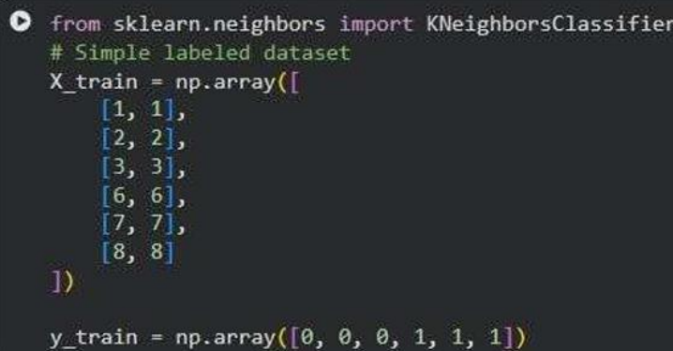
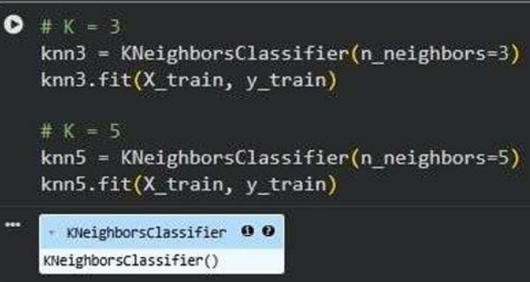
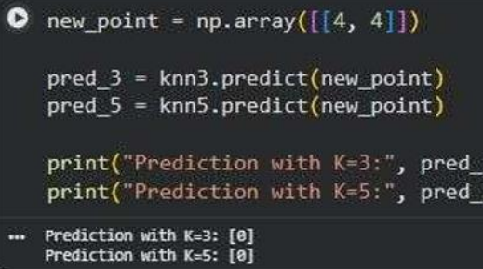

Lab # 13

Outlier Detection
Outlier Detection
- Outliers are data points that differ significantly from most other data points.
Distance-Based Outlier
- A point is an outlier if it has very few neighbors within a specified distance (R).
- Idea: Far from others = Outlier
Isolation Forest
- An anomaly detection algorithm that randomly splits data.
- Outliers are isolated faster and have shorter path lengths.
- Idea: Easy to isolate = Outlier
Common Datasets
- Iris Dataset
- Credit Card Fraud Dataset
- Wine Quality Dataset
- Breast Cancer Dataset
Purpose
- Used to detect anomalies and evaluate outlier detection algorithms in real-world scenarios.
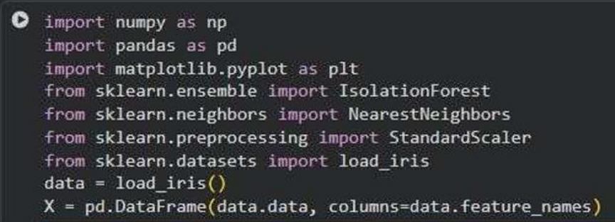
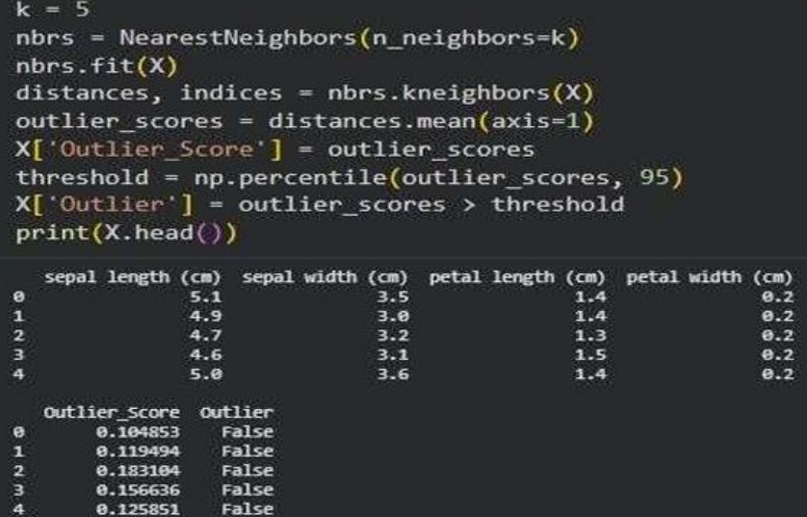
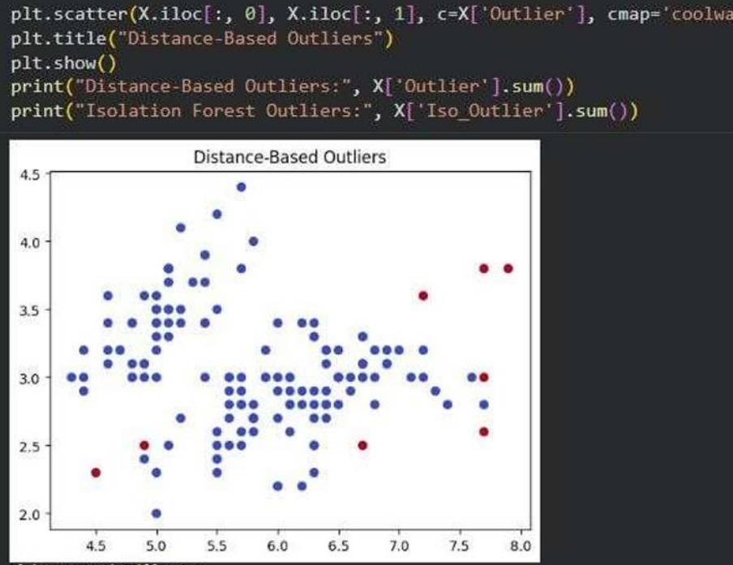

Lab # 14

Scraping & Sentiment Analysis
Objective
- Understand Sentiment Analysis and classify text sentiment using the VADER Sentiment Analyzer in Python.
Theory
- Sentiment Analysis is an NLP technique used to determine whether text is Positive, Negative, or Neutral.
- It helps analyze opinions from reviews, social media, surveys, and feedback.
- The goal is to understand people's feelings about a product, service, event, or topic.
VADER Sentiment Analyzer
- A rule-based sentiment analysis tool designed for social media and short texts.
- Generates four scores:
  - Positive
  - Negative
  - Neutral
  - Compound (overall sentiment score from -1 to +1)
Applications
- Product Review Analysis
- Social Media Monitoring
- Customer Feedback Evaluation
- Brand Reputation Management
- Market Research
- Political and Public Opinion Analysis
Advantages
- Automates opinion analysis
- Saves time and effort
- Helps understand customer needs
- Supports data-driven decisions
Limitations
- Struggles with sarcasm and irony
- Context-dependent meanings
- Less accurate for domain-specific language
- Difficult to classify mixed sentiments accurately
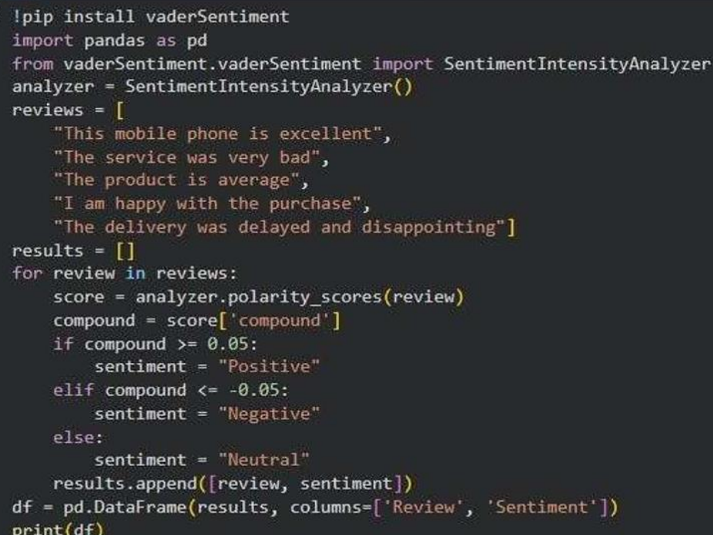
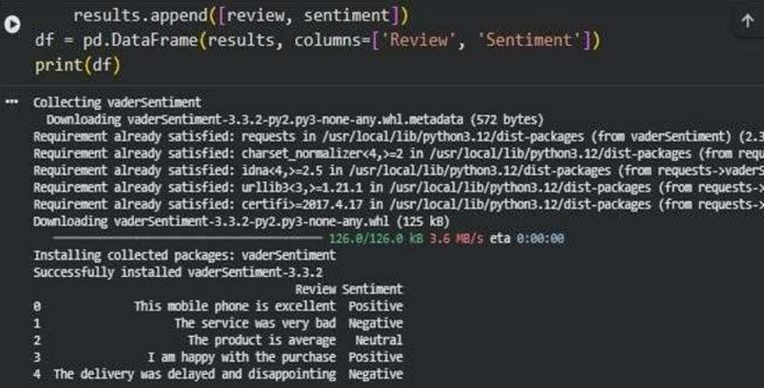

Lab # 15

Final Capstone Customer Review Analysis & Product Recommendation System
Objective
- Build a complete data mining system using data preprocessing, sentiment analysis, classification, clustering, and recommendation techniques to analyze customer reviews and support business decisions.
Real-World Scenario
- E-commerce companies receive thousands of reviews daily.
- Automated analysis helps identify customer sentiment, customer groups, and product recommendations.
Dataset
- Review ID, Customer ID, Product Name, Category
- Review Text, Rating, Purchase Date
- Customer Age, Location
- ~10,000 records with text and numerical data
Tools & Libraries
- Pandas, NumPy, Scikit-Learn
- Matplotlib, Seaborn
- NLTK, VADER Sentiment Analyzer
Learning Outcomes
- Clean and preprocess data
- Handle missing values and duplicates
- Perform sentiment analysis
- Train classification models
- Cluster customers using K-Means
- Generate product recommendations
- Evaluate model performance
- Extract business insights

Project Workflow
1. Data Collection
- Load dataset, inspect records, verify data types.
2. Data Cleaning
- Remove duplicates
- Handle missing values
- Standardize text
- Remove irrelevant data
3. Sentiment Analysis
- Use VADER to classify reviews as:
  - Positive
  - Negative
  - Neutral
4. Classification
- Models:
  - Decision Tree
  - Naïve Bayes
  - SVM
- Metrics:
  - Accuracy
  - Precision
  - Recall
  - F1-Score
5. Customer Clustering
- Apply K-Means clustering.
- Group customers by:
  - Purchase Frequency
  - Ratings
  - Spending Behavior
6. Recommendation Analysis
- Use Apriori and FP-Growth.
- Metrics:
  - Support
  - Confidence
  - Lift
- Recommend products often purchased together.
7. Visualization
- Sentiment Distribution
- Customer Clusters
- Top Products
- Association Rules

Sample Results
- 72% Positive Reviews
- 18% Neutral Reviews
- 10% Negative Reviews
- 4 Customer Segments Identified
- Top Product Pair: Mobile Cover → Screen Protector

Business Insights
- Customers are mostly satisfied.
- Electronics category has the highest engagement.
- High-spending customers are mainly in Cluster 2.
- Product bundles can boost sales through cross-selling.

